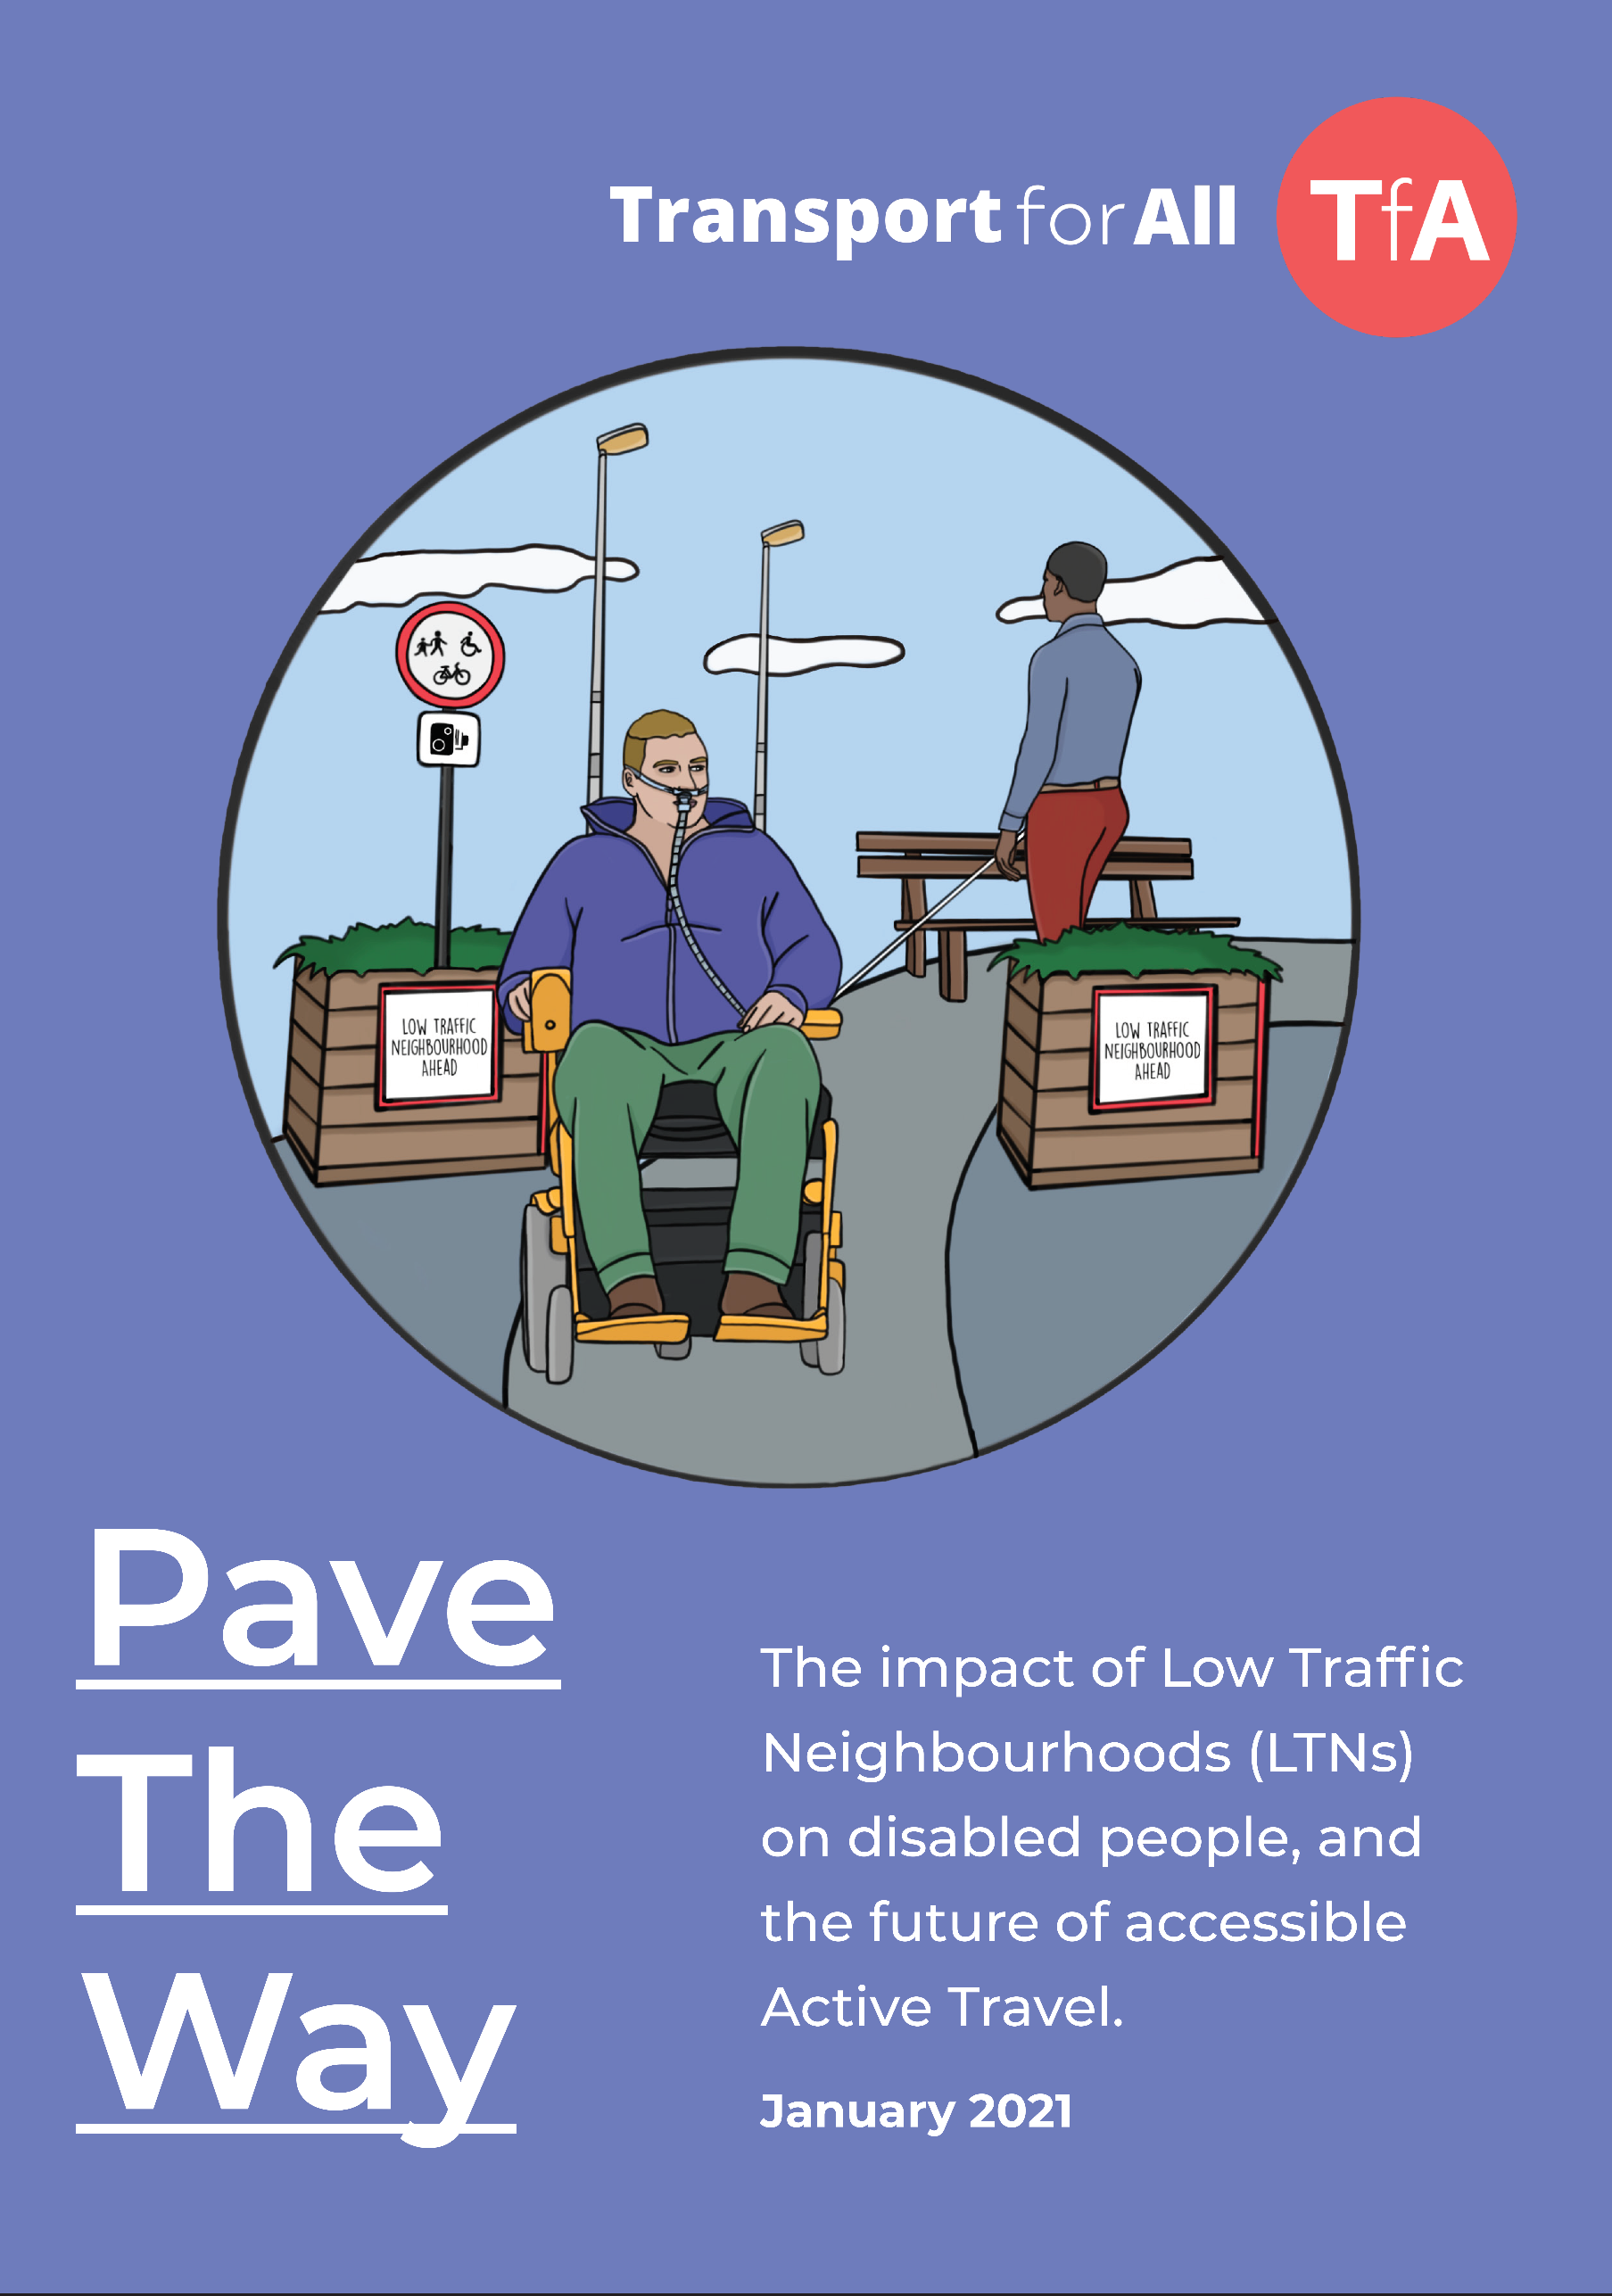

**Easy Read**

Sarah Teichler

[Company name]  [Company address]

[Document title]

|  |
| --- |
| **Contents** |



|  |  |
| --- | --- |
| Introduction | **Page 2** |
| How we did our research | **Page 6** |
| Access barriers to Active Travel faced by disabled people | **Page 11** |
| What we found out | **Page 14** |
| How do local Councils consult (ask for opinions) about LTNs? | **Page 22** |
| Solving the problems with LTNs and Active Travel | **Page 24** |
| Words used in this report that you might not know | **Page 28** |

|  |  |
| --- | --- |
| **Introduction** | |
|  | **‘Active Travel’ and ‘Low Traffic Neighbourhoods’** |
| CloseClose | Lots of people have chosen not to travel on public transport during the coronavirus pandemic. |
|  | Instead, people have been using ‘Active Travel’ more. Active Travel means making journeys without using public transport, such as buses, or cars. It includes walking and cycling. |
|  | The Government and local Councils want to encourage more people to use Active Travel. One of the things they are doing is to make some areas ‘Low Traffic Neighbourhoods’, also called LTNs. LTNs are areas where cars and buses are not usually allowed to go. |

|  |  |
| --- | --- |
|  | Most LTNs are in residential areas, which means areas where lots of people live, not town centres or other places with lots of businesses. |
|  | **What do people in general think about LTNs?** |
| **No**  **Yes** | LTNs are ‘controversial’. Controversial means something that lots of people have very different ideas about and argue with each other about. |
| CloseClose | Local Councils think that LTNs are a good idea. They say that LTNs can make it easier for people to walk and cycle, and that this means:   * cleaner air * fewer car and bus crashes |

|  |  |
| --- | --- |
|  | Some people think that LTNs are a bad idea. They say that disabled people who live in or near LTNs have to drive further and wait longer in traffic because they are not allowed to drive through the LTN. |
|  | **What do disabled people think about LTNs?** |
|  | Transport for All have done some research about LTNs. Research means asking questions and finding out answers. In our research we asked disabled people what they think instead of speaking for them. |
| CloseThumbs up signThumbs up sign | We learned that:   * Some disabled people living in or near LTNs think they are good, and some think they are bad * Many disabled people feel that they are not being asked for their views about Active Travel and LTNs and are not being listened to. |
|  | We think that because the Government and local Councils have not asked for or listened to disabled people, this means that:   * The way that LTNs have been designed has had a negative impact on some disabled people. Negative impact means bad effect. * Nothing has been done to make it easier for some disabled people to walk and cycle. |
| Thumbs up sign | But we also think that LTNs have a positive impact on some disabled people. Positive impact means good effect. Because of this we don’t think that LTNs should be completely stopped. |
|  | We think the Government and local Councils need to work with disabled people to make sure that Active Travel and LTNs are accessible and inclusive. |

|  |  |
| --- | --- |
| **How we did our research** | |
|  | **What kind of research did we do?** |
| **?** | The question that we wanted to answer was:  “What impact have Low Traffic Neighbourhoods had on disabled residents?’  Impact means effect. Residents are people who live in or near and LTN. |
|  | We decided that the best way to do our research was to interview disabled people and ask open-ended questions. Interviews are conversations where one or more person asks another person questions. Open-ended questions don’t have set answers to choose from so that the person being asked can answer any way they want to. |

|  |  |
| --- | --- |
|  | **What did we do?** |
| See the source image | We used lots of different ways to find people to interview, including:   * Social media like Twitter and Facebook * Newsletters * Local Deaf and Disabled People’s Organisations |
|  | All the people we interviewed:   * Are a disabled person or someone who is the main supporter for a disabled person * Live in or near an LTN |
| Laptop | The Coronavirus pandemic meant that we were not able to meet people in person. So, the interviews were done through ‘Zoom’, which is an online video service for meetings. We booked interpreters for Deaf people who use British Sign Language (BSL).  We also had phone conversations or written answers for people who cannot use Zoom. |
|  | **Who did we interview?** |
|  | We interviewed 84 disabled people or people who provide support for a disabled person.  78 of the 84 interviews we did gave us information that we could use in our research.  The disabled people we spoke to or about were all very different. |
|  | They were aged between 8 and 89. |
|  | They had different types of impairments, including:   * mobility impairments * mental health conditions * visual impairments |
|  | Some had a car and some did not. Some had a Blue Badge and some did not. |
|  | Lots of the people we interviewed lived in London. We interviewed people who lived in 19 of the 21 London Boroughs (Council areas) that have LTNs.  We also interviewed people who live in places outside London that have LTNs:   * Newcastle * Manchester * Yorkshire * Woking * Edinburgh * Oxford |
|  | **What did we do with the information from the interviews?** |
|  | We had recorded the Zoom interviews, and we played them back and typed everything that was said. |

|  |  |
| --- | --- |
| **Topics** | We organised all the information from the interviews into topic groups. We gave each topic a different name so that we could easily see when different people were telling us the same thing. |
|  | **Other research we did** |
| See the source imageLaptop | Because of the Coronavirus pandemic we had to mostly use ‘digital’ ways to interview people. Digital means using a computer and using the internet. |
| CloseLaptop | This is a problem because some disabled people face barriers to using computers or the internet. This can include people with visual impairments, Deaf people and people with learning difficulties. |
| cid:image003.gif@01D6F016.D3B2DE70 | We decided to have group meetings with some groups of people to make it easier for them to take part. The things we learned from them have helped us to write this report. |
|  |  |
| **Access barriers to Active Travel faced by disabled people** | |
|  | It is important to remember that some disabled people cannot walk or cycle because of their impairments or access needs. |
|  | **Accessibility issues with streets** |
|  | 42 percent (42 out of 100) of the people we interviewed talked about accessibility issues with streets. This is one of the biggest barriers to Active Travel for disabled people. |
|  | For walking and wheeling, anything that gets in the way on pavements is a problem for disabled people. |
| See the source image  Close | For cycling, cycle routes have been designed for ordinary bikes with two wheels and not for adapted or accessible bikes. |
|  | **Cost** |
|  | For cycling, adapted and accessible bikes can be a lot more expensive than ordinary bikes with two wheels. The cost of an adapted or accessible bike can be anything from £500 to £3,500.  **£££** |
|  | For walking and wheeling, some disabled people don’t have the right mobility aids for making journeys on the streets. |
|  | **Awareness and attitudes** |
| Close | As well as the barriers already mentioned, some disabled people don’t know about that they might be able to cycle. They might never have seen disabled cyclists and might not know about adapted and accessible bikes. |

|  |  |
| --- | --- |
|  | It is up to an individual disabled people to decide for themselves whether they want to use a mobility aid to help them walk, wheel or cycle. But it is important that they are given the chance to use Active Travel if they want to, and at the moment there are lots of barriers to this. |
|  |  |

|  |  |
| --- | --- |
|  | **What we found out** |
|  | **People told us they have different views about LTNs** |
| **No**  **Yes** | The first thing we found out is that disabled people have strong views about LTNs. 83 percent (83 out of 100) of the people we interviewed told us they feel strongly impacted (affected) by LTNs. |
|  | 33 percent (33 out of 100) of the people we interviewed talked about how everyone seems to have a different view of LTNs. Lots of people told us their views are not being listened to by people who feel differently. |
| Thumbs up signThumbs up sign | Some of the people we interviewed feel very positive (good) about LTNs and some feel very negative (bad) about LTNs. |
|  | Some people think that LTNs could be a good idea but they haven’t been done in the right way. They feel that this has caused problems. |
|  | **People told us that arguing about LTNs causes bad feelings** |
|  | Some people told us that LTNs are causing arguments in their local community and with their family and friends. |
|  | 50 percent (half) of the people we interviewed told us they had negative feelings about the arguments that LTNs are causing. |
|  | But not all of the negative feelings that people talked about were just about LTNs. The Coronavirus pandemic is making people feel frightened, annoyed and lonely. This has been worse for disabled people. |

|  |  |
| --- | --- |
| **?** | **More research needs to be done to find out what difference LTNs have made** |
| Question markQuestion mark | Some of the conversations about LTNs have been about whether they have made traffic better or worse. |
|  | Some of the conversations have been about whether LTNs have made pollution better or worse. |
|  | Our research was not about the amount of traffic and pollution in LTNs. We think research should be done by the right people in the right way to answer these questions. |
| Thumbs up sign | **Some people told us positive things about LTNs they live in or near** |

|  |  |
| --- | --- |
| Close | 18 percent (18 out of 100) of people told us that there was less traffic danger. Most of these were Deaf or visually impaired people. |
| Checkmark | Less traffic danger means that people feel safer when they on the streets. Feeling safer can help people make independent journeys. 6 percent (6 out of 100) people talked about feeling more independent and having more freedom to travel. |
| Closecid:image003.gif@01D6F018.6C568860 | 17 percent (7 out of 100) people told us that there was less traffic noise. Many of these were deaf or neurodivergent people. |
| Close | Too much noise can cause problems for some people with autism or similar impairments. They might be upset, confused or in pain because of it. This is called ‘sensory overload’. Quieter roads are better because there is less chance that people will have sensory overload. |
| Checkmark | Too much noise can also cause problems for some visually impaired people. This is because they are more likely than other people to use sounds to decide when it is safe to cross the road. Quieter roads mean that it is easier to listen to just the useful sounds. |
|  | 14 percent (14 out of 100) of people told us that less traffic danger and noise meant that their journeys were easier or nicer. |
| Checkmark | Some people told us that they were walking, wheeling or cycling more. This is helping them to be more healthy. |
|  | People who told us about a positive impact because of their LTN also said that this was helping them to have good mental health. |

|  |  |
| --- | --- |
| Thumbs up sign | **Some people told us negative things about LTNs they live in or near** |
|  | LTNs push traffic from smaller roads onto main roads, so some journeys are a longer distance than they were before the LTN. 77 percent (77 out of 100) of people told us that their car journeys took longer than they used to. |
|  | 20 percent (20 out of 100) people told us that their physical health or impairment was worse because they had to spend longer in the car. |
| **£££** | Longer journeys can also be more expensive because of extra petrol or taxi fares. Disabled people are less likely to have a job so extra costs are more of a problem. |

|  |  |
| --- | --- |
|  | Some people told us that taxi drivers didn’t want to travel further to pick them up. Sometimes they would ask the person to meet them at the other end of the street. This can be difficult for some visually impaired people and some mobility impaired people. Sometimes the taxi driver said they would not pick the person up. |
|  | Longer journeys can also be difficult for people who travel to disabled people’s houses to provide them with support. This includes carers, Personal Assistants (PAs), support workers and district nurses. They are sometimes delayed because of the longer journey and arrive late for the appointment or miss it completely. |
| cid:image003.png@01D6F019.6E113B40 | 46 percent (46 out of 100) people said that journeys had become more difficult, which meant having less freedom and being more lonely. |

|  |  |
| --- | --- |
| CloseSee the source image | LTNs have changed the routes that some disabled people have to take for their journey. Some disabled people find this difficult because they have a ‘mental map’ (picture in their head) of the route which is no longer right. Some disabled people find change difficult. |
|  | 33 percent (33 out of 100) of people told us that there was more traffic danger than before and they felt less safe. This could be because of drivers behaving badly. Some people told us about dangerous driving or cycling in LTNs. |
| Close | 19 percent (19 out of 100) people told us that they had less independence than before. This is because problems accessing Active Travel and public transport means that the car is the only way they can make a journey. |
|  |  |

|  |  |
| --- | --- |
| **How do local Councils consult (ask for opinions) about LTNs?** | |
|  | After the start of the Coronavirus pandemic, local Councils did not have to consult with local residents (people who live there) before they made an LTN. |
| Close | When Councils tell residents about a new LTN they do not always do this in an accessible way. For example, a leaflet posted through the door will be inaccessible to a visually impaired person. 72 percent (72 out of 100) people told us that they were annoyed with the way that the Council told them. |
|  | If Councils do consult about LTNs this is often inaccessible and disabled people are often left out. This can be because:   * A lot of jargon is used when talking about LTNs. This can be difficult for Deaf people who use British Sign Language (BSL) and people with cognitive impairments to understand. * CloseLaptopSometimes feedback can only be sent through a website. But we found that one of the websites used by Councils is not accessible to people who use screen readers. |
|  | Some Councils have done an Equality Impact Assessment of the LTN. Equality Impact Assessments are also sometimes called EqIAs. Doing an EqIA means thinking about what effect the LTN might have on disabled people and other groups of people and making a plan to solve any problems it causes. |
| Close  Equality Impact Assessment | But we think that some of the EqIAs Councils have done are not very good. This is because they have not spoken to disabled people to find out what the impact of LTNs might be. |
| Close | We also think that when some Councils count how many disabled residents live in or near an LTN, they miss some people out. Some Councils only count people who get benefits for disabled people, but not all disabled people get benefits. |

|  |  |
| --- | --- |
| **Solving the problems with LTNs and Active Travel** | |
| Thumbs up signThumbs up sign | **The problems**  Our research shows that LTNs have a positive impact on some disabled people but a negative impact on others. |
|  | Disabled people are often not able to make Active Travel journeys for all the reasons we have explained. Nothing has been done to take away the access barriers to Active Travel. |
|  | Sometimes disabled people are only able to travel using a car, and LTNs make their journeys longer. |

|  |  |
| --- | --- |
|  | Not consulting with disabled residents about LTNs has made them feel ignored and caused them to argue with each other. |
| Lightbulb idea light bulb clip art at vector wikiclipart | **Solutions (ways of solving a problem)** |
|  | Because LTNs have a positive impact on some disabled people we don’t think that they should be stopped completely. But we do think that:   * Some things need to be done to solve the problems that LTNs cause for disabled people. * Some things need to be done to take away the access barriers that disabled people face to Active Travel. |

|  |  |
| --- | --- |
| Lightbulb idea light bulb clip art at vector wikiclipartExclamation mark | Our ideas for solutions that need to happen quickly are: |
|  | * Checking that each LTN is as accessible as it can be – for example, checking that pavements are wide, smooth and clear enough and that road crossings have dropped kerbs and tactile paving. |
|  | * Instead of changing an area to an LTN in one go, making changes bit by bit. |
|  | * Using cameras which can read car number plates (ANPR camera) to let some cars use LTNs. |

|  |  |
| --- | --- |
| Lightbulb idea light bulb clip art at vector wikiclipart | Our ideas for solutions that could happen further away in the future are: |
|  | * Making pavements, cycle lanes and roads around each LTN more accessible. |
|  | * Helping disabled people to pay for adapted and accessible bikes and good quality wheelchairs. |
|  | * Co-producing (working together in a team) with disabled people to make decisions about LTNs and other Active Travel plans. |

**Words used in this report that you might not know**



Words that are underlined are also in the table below.

|  |  |
| --- | --- |
| ANPR camera | ANPR stands for Automatic Number Plate Recognition. An ANPR camera reads car number plates and can tell from this what type of the car it is and who it belongs to. |
| Benefits | In this report, benefits mean welfare benefits. Benefits are money that the Government pays to people like Universal Credit, Personal Independence Payment, Disability Living Allowance or Carers Allowance. |
| Borough | A Borough is an area run by a Council. |
| Controversial | Controversial means something that lots of people have very different ideas about and argue with each other about. |
| Co-producing | Co-producing means working together to make decisions and plans. In this report, we are talking about local Councils co-producing with disabled residents. |
| Coronavirus | Coronavirus is a disease that makes people ill. At the moment, lots of people all over the world have Coronavirus. This is called a pandemic. |
| Digital | Digital means using a computer and using the internet. |
| Dropped kerbs | A dropped kerb is a small ramp cut into the kerb so that wheelchair users can get across the road. |
| EqIA | Equality Impact Assessment. |
| Equality Impact Assessment | Doing an Equality Impact Assessment means thinking about what effect something might have on disabled people and other groups of people and making a plan to solve any problems it causes. |
| Excluded | Excluded means left out. Disabled people are often excluded. |
| Impact | Impact means effect. Saying ‘it impacts on someone’ means ‘it affects someone’. |
| Interview | Interviews are conversations where one or more person asks another person questions. |
| Low Traffic Neighbourhoods | Low Travel Neighbourhoods are areas where cars and buses are not usually allowed to go. |
| LTNs | Low Traffic Neighbourhoods. |
| Mental health | Mental health means how we are feeling and how well we can cope with the problems we have. |
| Mental map | In this report, someone’s mental map means a picture that they have in their head of the route for a journey. |
| Negative | Negative means bad or unhelpful. |
| Neurodivergent | People who are neurodivergent see and think about the world in a different way from most other people. There are lots of conditions and impairments that can make people neurodivergent, like autism or ADHD. |
| Open-ended question | Open-ended questions don’t have set answers to choose from so that the person being asked can answer any way they want to. |
| Pandemic | A pandemic is when lots of people all over the world get the same disease. At the moment, we have a Coronavirus pandemic. |
| Positive | Positive means good or helpful. |
| Research | Research is asking questions and finding out answers. One of the ways that research can be done is through having conversations with people and asking them open-ended questions. |
| Resident | A resident means someone who lives in a particular place. In this report we talk about residents who live in or near an LTN. |
| Residential areas | Residential areas are areas where lots of people live, not town centres or other places with lots of businesses. |
| Sensory overload | People get information about the place they are in through their senses – seeing, hearing, smelling, tasting and touching. Sensory overload is something that people with autism or similar impairments might feel because they are getting too much information through their senses – for example the place they are in is very noisy. Sensory overload can make someone feel upset, confused or in pain. |
| Solutions | Solutions are ways of solving a problem. |
| Tactile paving | Paving is the hard surface of pavements. Tactile paving has bumps or ridges which people can feel under their feet when they walk over it. It is there to warn visually impaired people to be careful, for example at a road crossing. |
| Zoom | Zoom is an online video service for meetings. If two or more people use Zoom together they can see and talk to each other using their computer. |

