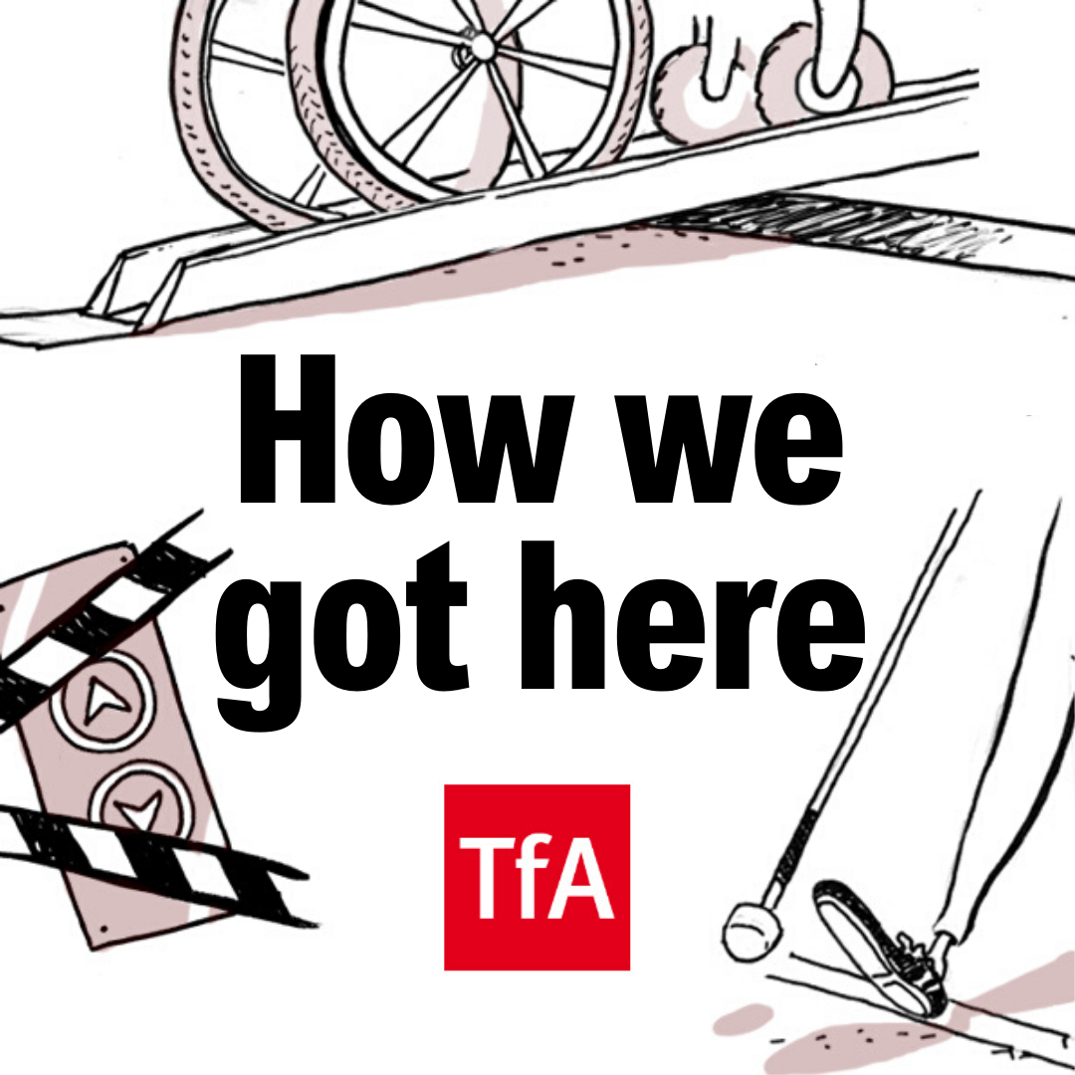

Episode 4: Dr Amy Kavanagh
Content notes: None.

Speaker information
- Katie Pennick (Interviewer)(Katie)
- Dr Amy Kavanagh (Amy)
- Alex Lopez (Alex)
- Passengers who try to flag driver’s attention when boarding the bus (PX, PY)

Transcribed by Academic Audio Transcription
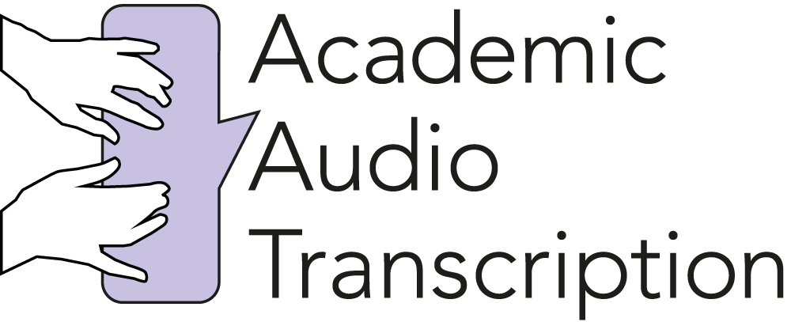

‘How We Got Here’ Transcript

Episode 4: Dr Amy Kavanagh

[Start of recording]

00:00:00 Amy You know, when I started using a white cane, I had a very close friend to me say, “You’re just lighter. You’re happier. Because you are being who you are.” And I was like, yeah, I think I finally am just being like, “Yeah, it’s fine to be me.”

[UPBEAT MUSIC PLAYS WITH STRONG BASELINE, CYMBAL HITS, HANDCLAPS AND THEN HORNS 00:00:13—00:00:29]

00:00:29 Katie [music bed continues] Welcome back. I’m Katie and this is How We Got Here, the podcast where I interview a notable disabled person as we make a journey together on public transport. En route, they’ll share with me stories from their life and I’ll learn how far disability rights have come in the UK and just how far there is to go. This is a podcast about movement, progression and change, and is brought to you by Transport For All, a leading disability rights organisation fighting for accessible streets and transport systems. This year is going to be bigger than ever for us, and if you fancy getting involved, just search for us online, sign up as a member or for our newsletter, and join a brilliant community of changemakers.

[UPBEAT MUSIC CONTINUES 00:01:11—00:01:15]

00:01:15 Katie [music bed continues] Today is the last episode of the series, and it is a brilliant one to end on. I’m meeting up with the marvellous Dr Amy Kavanagh, the academic, campaigner, activist and Twitter sensation. Remember, you can find transcripts for all our episodes on our website. Just go to transportforall.org.uk/podcast. Let’s go!

[MUSIC BED FADES 00:01:39]

[TRAIN STATION BACKGROUND SOUNDS 00:01:44]

00:01:47 Katie I’m here in Angel Station in Central London and I’m just waiting to meet my guest for this episode. Her name is Dr Amy Kavanagh. She is an academic, activist and campaigner. She is also visually impaired and uses a long white cane and has started documenting the number of times people touch, grab or pull her without consent, using the hashtag #DontGrabJustAsk on Twitter. This hashtag has really started a conversation around unwanted touching for disabled people under the guise of assistance. I’ve followed her and her work online for so long and I’m thrilled to be able to finally meet her in person today.

00:02:28 Katie Hi Amy!

00:02:30 Amy Hi!

00:02:31 Katie Hi, how are you?

00:02:32 Amy I’m very well thank you.

00:02:33 Katie You made it here!

00:02:34 Amy I did. I had a slight travel snafu but I’m fine now.

00:02:36 Katie A ‘snafu’? That’s a good, great term to use there.

00:02:41 Amy So!

00:02:41 Katie Right, so where are we off to today?

00:02:43 Amy We’re going to go off to the British Library.

00:02:44 Katie Excellent.

00:02:45 Amy Have a bit of a studious time.

00:02:46 Katie It is.

00:02:47 Amy Living back my academic life. So we’re going to get on the 73, on the bus together, and we’re going to do a little bit of kind of guiding. So shall we get started?

00:02:56 Katie Absolutely. So I mean, you know, I’ve never done this before. I’ve never sighted for someone before, and am I right in thinking you’ve never been guided by a wheelchair user before?

00:03:06 Amy No I have not, no.

00:03:07 Katie So this is a first for both of us?

00:03:08 Amy It is a first for everyone.

00:03:09 Katie So we’ll give it a go.

00:03:10 Amy We’ll give it a go.

00:03:11 Katie And you will have to explain to me fully, start from the basics, exactly what I need to do in order to assist you the best way possible.

00:03:19 Amy So I’m going to use the lovely Alex to kind of start explaining the principles, okay?

00:03:21 Katie Yes, my boyfriend and glamorous assistant is here to help.

00:03:24 Amy So this is, you know, some of the things we’re going to talk about, like if you do want to offer to sighted-guide a visually impaired person, this is how to go about it. So I’m stood here. If Alex introduced himself and said, “Hi, would you like some assistance?”

00:03:37 Alex Hello, I’m Alex. Would you like some assistance?

00:03:38 Amy And then if he came—I use my cane in my right hand, so I want to be guided on my left side. So if Alex comes and stands on my left side next to me. And then kind of just, touch your arm against my arm and then I know where it is. So then I would hold, in the sort of crook of Alex’s elbow is where I like to hold someone’s arm, but people hold a shoulder or something like that. So now Alex if you can guide me round to the back of Katie’s chair and we can figure this out!

00:04:07 Katie I use a manual wheelchair, but it does have handlebars.

00:04:12 Amy So I’m now behind Katie’s chair. I’m now going to have to fondle Katie and her chair a little bit. I’m going to let go of Alex and then I’m just going to check where your shoulders are. So your shoulders are there. Can you do a movement as if you are going to wheel your chair so I can just feel what your arms do?

00:04:26 Katie Of course. So I am moving my arms into the position that I push my wheelchair in.

00:04:32 Amy Okay. That’s fine.

00:04:32 Katie So they’re now hovering above my wheels.

00:04:35 Amy I think this should be fine.

00:04:36 Katie Okay.

00:04:37 Amy I need to keep moving my cane so I can feel changes in surfaces and stuff.

00:04:41 Katie Okay.

00:04:42 Amy But I reckon we can give it a go now, if you’re—and I’m going to be stepping about back here. And then I think we’ll be pretty safe.

00:04:48 Katie Great. And we’re going go! Okay so—

00:04:50 Amy Yeah, no, this is working. Oh no, that’s great!

00:04:53 Katie Great! So what kind of information can you pick up from holding the handlebar of my wheelchair?

00:05:00 Amy More than I thought which is good. So… I hate to compare you to a trolley, Katie.

00:05:08 Katie [laughs] No, go ahead!

00:05:10 Amy But my only experience otherwise is—oh yeah, so I can feel you getting that dip really well.

00:05:14 Katie Right. So you can feel the bumps and the dips and the steps?

00:05:17 Amy Yeah!

00:05:20 Katie And because I’m slightly ahead of you, if I go over a step, does that sort of alert you to the fact that you are about to go over a step?

00:05:25 Amy Yeah.

00:05:25 Katie Excellent.

00:05:26 Amy And I can feel you turning very smoothly.

00:05:28 Katie Oh great. So in addition to surfaces of the road and directions, which of course you can sort of feel from the movement of my chair, what extra information is it useful for me to describe to you as we’re going along around you?

00:05:44 Amy So if there’s going to be like a hazard, like a step, or if we’re coming to a road crossing. If we have to stop suddenly, it’s good to alert me in case there’s like a phone zombie or something.

00:05:57 Katie Okay.

00:05:59 Amy And then I won’t—

00:05:59 Katie Sorry, wait, sorry, a phone zombie?

00:06:01 Amy Yeah, so a person looking at their phone not looking where they’re going!

00:06:03 Katie [laughs]

00:06:04 Amy I’m sure you encounter phone zombies as well.

00:06:06 Katie I do. Ah, they end up on my lap most of the time. [laughs]

00:06:09 Amy Are we stopping here?

00:06:10 Katie Yes. So we are at the bus stop and we are getting the 73, which I will flag down. So it’s interesting because, as I’ve done a few of these journeys now for this podcast and going out on a journey with another disabled person. But due to the fact that I use a wheelchair and quite often the people that I’m interviewing also use wheelchairs, we haven’t been able to get on a bus because [chuckling] of course there’s only one wheelchair spot.

00:06:43 Amy Yeah.

00:06:43 Katie So but we will be able to get the bus together, which is nice.

00:06:46 Amy We will. How we will board the bus will be exciting.

00:06:49 Katie Interesting! [chuckles] So do you usually go on the front or the back of the bus?

00:06:54 Amy So I normally try and sit in one of the priority seats, depending on the layout of the bus. Buses can be challenging that way because they have different layouts. There are normally some seats before the next set of doors. I can get to those and find those relatively quickly and easily, but if people don’t want to give up their seats in those spaces, or they might need to use them themselves, then I have to kind of venture into the depths of the bus which can be tricky because then the bus is moving and….

00:07:26 Katie Here’s our bus now, so I’m just flagging him down.

00:07:30 Amy Is he going to…?

[BUS RAMP NOISES 00:07:31]

00:07:33 Katie Yeah, he’s seen us. So the ramp is coming out.

00:07:40 Amy Okay. I’m going to let you do this solo Katie.

00:07:42 Katie Okay. Will you come on behind me?

00:07:44 Amy I’ll come on behind you.

00:07:45 Katie Right.

00:07:45 Amy Just shout when you’re on.

00:07:46 Katie Okay!

00:07:49 Amy So is she on?

00:07:49 Katie Yep, I’m in the bus.

00:07:50 Amy Okay. I’m coming up the ramp! [BUS RAMP RETRACTION NOISES 00:07:52] Oh, apparently not.

00:07:54 PX Driver, the door! Driver!

00:07:57 PY Open the door again! The lady’s waiting to get on.

00:08:01 Amy I’ll get on the front, don’t worry. Hiya. I’ll get on the front. Exciting adventure!

00:08:08 Katie So that was—[laughs]. How would you say that went?

00:08:12 Amy Ah, mixed. Somewhat what I expected to be honest.

00:08:15 Katie To describe what happened there, the backdoors opened, the ramp came out, I got on the ramp.

00:08:19 Amy Because I couldn’t be guided, it’s not wide enough for Katie and I to board together.

00:08:24 Katie But then unfortunately the doors were shut straight after me leaving Amy on the street, so you had to go through the front doors instead.

00:08:33 Amy Yeah.

00:08:35 Katie So, getting around, buses, tubes, trains, everything. What are some of the most, the biggest difficulties that you come up against?

00:08:44 Amy I would say the biggest barriers, for me, are not really around the kind of physical infrastructure of transport that might be for you and other wheelchair users. If it’s step-free, at the moment, I’m fine. I’m having to wait longer for a guide dog because I need a guide dog that can do escalators, and that makes the wait longer, so that is one challenge that’s a bit frustrating. But for me it’s actually the behaviour of other people on transport that are one of the main barriers to me being able to use it equally as a disabled person. Whether that be, in this instance, staff maybe not following best practice—shutting a door in my face—or, you know, with buses, that bus didn’t pull up right next to us, so we then had to kind of navigate through a crowd of people to try and board it, which was half of the issue. Buses, when they see a visually impaired person, they’re supposed to pull the door, like pull right up next to you on the doors so I can instantly find the doors and not have to get through people and not get pushed and stuff. When that doesn’t happen, it’s quite stressful. I guess the only big issue around London that is about kind of access in the physical environment is pavements. So, as we will discover when we potter around a lot, the way I have to use a pedestrian crossing is very specific. I need tactile pavements to tell me where road crossings are.

00:10:13 Katie And are they generally around? At crossings?

00:10:16 Amy In Central London it’s pretty good.

00:10:18 Katie Okay.

00:10:19 Amy The consistency of how they are laid out is not good. So there is guidance. It’s supposed to be particular colours, particular layouts. You’ll notice there are different textures; they mean different things. And you know, like a design planner will come along and be like, “Oh well, that doesn’t look pretty enough so I’ll put in something else,” and then that sends me completely the wrong information. One of my biggest bugbears at the moment is the dockless bikes. So these new bike schemes where you can just use an app, you can use a bike, you can cycle it around, and then you can just leave it anywhere. And often people are leaving it in the middle of the pavement, people are leaving them across roads and crossings. So I’ve had my fair share of handlebar bruises from just walking into it because it’s in the middle of the pavement, I don’t know it’s there, or it takes me a very long time to navigate around them. And then that can make me really disorientated.

00:11:22 Katie Yeah. But sort of going back to what you were saying about other people and would that be staff but also other passengers?

00:11:29 Amy Yes.

00:11:29 Katie What are the biggest sort of obstacles that you were confronted with there when travelling and getting around?

00:11:36 Amy So something that I have been campaigning around is that a lot of people grab me and touch me without asking. It did in fact happen as I was [chuckling] getting into this seat, as you may have seen. And it can be very disorientating. Like, that instance it wasn’t too bad. I was already on my way to the seat. But I don’t really need to be manhandled into a seat. You know, I’m an adult. I’d found the seat. I knew where it was. I’m obviously with people who could support me if I wanted that support. But yeah, pretty much every day, total strangers touch me. I get pulled on and off buses. I get dragged into trains. I get pulled across roads. I get steered around shops. And people do it without asking me if I want any help. And often, it’s really counter-productive. Because yes, they may well have good intentions, but suddenly being dragged into a road before you’re ready to cross it is terrifying. It’s really frightening when you’re waiting at a road crossing, and because I have to rely on my hearing, so there’s either the beeping or there’s a little tactile spinning cone underneath the button box, and those two things can tell me when to cross. So when I’m waiting for that signal, either the auditory one, or the tactile one, and someone drags me into the road, and I know it’s not yet safe to cross, but they think, “Oh well, she doesn’t know, I’m just going to take her across the road.” They don’t know how fast I walk; they don’t know how I use my long cane. I’m often—quite often people will grab the arm that my cane is in, so then I lose contact with the ground, so then I don’t know when we’re going to come up to a kerb. And people will often do this with saying nothing to me.

00:13:28 Katie Not even a “Hello”?

00:13:29 Amy “Hi,” “Do you need a hand?” Like I am just suddenly in the middle of a road with like mopeds whizzing around me, and someone has got hold of me and I have no idea what their intentions are, because I have had people have unpleasant intentions. And I’ve had people try to steal my bag, people harass me, people sexually assault me, as an excuse to use help. So yeah, I would say that is the thing that affects my confidence and my ability to use transport is the behaviour of other people. I think the issue is that there’s such a lack of awareness around how visually impaired people navigate the world, how I use my long cane. People—and to be honest, before I started using it, I also thought this. I thought, you know, it’s just a symbol. It’s just a big like, having a big sign, like, “Hello I’m the blind person sign.” But actually now I use it, it’s like… it’s like a new sense, you know? It’s… it’s like really helpful, and it gives me this whole picture of the world through these sensations and vibrations that I didn’t have before. So there’s different types of white cane, and people might see people have different ones. But the long cane that I use, and I sweep across the floor, sometimes people tap it. I tap it depending on the situation. Sometimes people just hold like a little small one, and it’s just like a, it’s called a ‘symbol cane’ just to indicate that they’re visually impaired but they’re not using it for mobility reasons.

00:15:08 Katie Yeah. So how long did it take you to learn how to best use it?

00:15:12 Amy Gosh, I think I’m still learning to be honest.

00:15:14 Katie [laughs]

00:15:16 Amy I don’t think you ever stop. It took me a good couple of months to be able to do it really safely and consistently, I would say. Okay, we’re approaching our stop. We’re going to have super fun getting off!

00:15:27 Katie Getting off the bus now as well as getting on! I’m pressing the button. Now…. [BUS RAMP SOUNDS 00:15:37] Okay fabulous, the ramp is being deployed.

00:15:40 Amy Hurray! We have ramp!

00:15:46 Katie Okay. I’ll see you out there.

00:15:50 Amy Okay, alright, I’m going to find you. I’m finding you. I’ve found you. I’m here.

00:15:55 Katie Are you happy?

00:15:56 Amy Happy! Are you happy?

00:15:57 Katie I am happy!

[UPBEAT MUSIC PLAYS WITH STRONG BASELINE BLASTS 00:15:58—00:16:02]

00:16:02 Amy So I am going to go and use the pedestrian crossing in the way that I normally would.

00:16:05 Katie Okay.

00:16:05 Amy Okay, if that’s alright?

00:16:06 Katie Absolutely. Just describe what you’re doing as you do it.

00:16:09 Amy So I am finding the post. I am finding the button box. I am going to hold onto, because I know this one doesn’t make a noise, so underneath the button box there is a spinning cone and that will spin, if it’s working, when it’s green. So it’s spinning now, and I am crossing.

00:16:25 Katie We are crossing the road.

00:16:26 Amy So I know this crossing, so this is one I can use independently. So I’m waiting to get to the tactiles on the other side, there they are, and then swinging a right, and I need to go and find the other button box now.

00:16:38 Katie And are they usually working or are they quite often not working?

00:16:41 Amy I would say… I learn which ones work, and then I use those crossings. There’s other indications that… you know, at this road it’s really busy, so if I can hear the engines have stopped and are idling I can presume that it’s probably safe. Or I can just double check with someone and say, “Oh, is it green?” Unfortunately that’s then quite often when people take it upon themselves to drag me across the road. Yeah, so like now I can hear those cars are idling. Some are still going. And I can hear other people moving as well. That can tell me it’s safe to cross. It’s a lot of using your ears.

00:17:19 Katie So we’re approaching the entrance of the British Library, and I know that we have to have our bags checked as we enter, so am going to stop recording because I need to take all my equipment off, and we will re…

00:17:33 Amy Reconvene!

00:17:34 Katie Reconvene on the other side. Cool.

[UPBEAT MUSIC PLAYS WITH STRONG BASELINE 00:17:36—00:17:44]

00:17:44 Katie We’re here in the British Library, which is definitely one of your haunts.

00:17:49 Amy [laughs] Yeah, well it used to be.

00:17:51 Katie [chuckles] Spent a great deal of time here. You can hear the tip-tapping of people’s laptops and studious concentration.

00:17:58 Amy The cogs whirring.

00:17:59 Katie The cogs are whirring! We were talking about white canes.

00:18:02 Amy We were.

00:18:03 Katie And I wanted to ask you about your, the white #CaneAdventures, and being able to catch on camera and have this go-pro footage of people tripping over your cane, jumping over it. I mean, how—you know, what was the initial motivation behind that? Did it sort of become…? It was a thing that was happening so frequently you decided to put it on camera?

00:18:24 Amy I do get some harassment, and the police said it’s a good idea to wear a camera, and then you get a bit less people harassing you.

00:18:31 Katie Wow.

00:18:32 Amy Yeah. Yeah! Slightly grim reason.

00:18:33 Katie And how often does this sort of thing happen to you?

00:18:37 Amy Probably about twice a month I get somebody using the opportunity to interact with me to ask me very personal questions, inappropriate questions, or try to touch me inappropriately, or make suggestions that they’re going to follow me, something like that. That happens probably, yeah, about twice a month.

00:18:59 Katie Are you wary of strangers?

00:19:00 Amy Yes. And that makes me really sad.

00:19:02 Katie Yeah.

00:19:03 Amy And I know that the overwhelming majority of people are not like that, but there are enough people who have been like that towards me that it just makes me really suspicious. And I know that’s an experience that especially other disabled women share. And that’s why I’ve been doing this new project, where I’ve been researching into the issue and collecting stories. So I’ve been collaborating with a criminologist from the University of Sussex called Dr Hannah Mason-Bish, and she is a very experienced criminologist that looks at hate crime. And she started following me on Twitter and sort of saw me talking about these experiences, and went and said, “Oh, I wonder what research has been done into this.” Zero. So together we’re now using a blog to collect people’s stories.

00:19:56 Katie And this is ‘Private Public, Public Spaces’.

00:19:58 Amy That’s it, yes.

00:20:00 Katie And what are the sorts of things that are coming through?

00:20:02 Amy So there are a few trends. We are mainly seeking women and non-binary people. That’s kind of this first stage of this project. That is because we are exploring that kind #MeToo experiences of sexual assault is a dynamic of it, and disabled women are twice as likely to experience sexual violence than nondisabled women. And that’s why we’re mainly focusing on women but obviously we recognise it does happen to men as well. And that’s going to be, hopefully, the next stage of the project is going to different groups of people. But one of the trends is that it does really affect people’s confidence. We have a lot of responses saying these kind of incidents—not necessarily just sexually motivated—but just the constant touching, the being harassed, the being asked invasive questions, people pushing wheelchairs without asking, people making comments about someone with an invisible condition needing a seat, that kind of thing, that it puts people off going out of the house on their own. And that is such a massive impact of what are not always malevolent behaviours, but often are, and I just, a lot of my campaigning has been about getting people to understand that their intentions are not always obvious, and actually really, you should treat disabled people like you would anyone else. We’re not just here to kind of receive, gratefully, your interactions with us [chuckling]. You know, we have autonomy; we have a desire to be independent; we have boundaries. We have the right to consent. And actually, talk to us like human beings, and then you can establish how you can be of assistance or not, instead of just, you know, jumping on in there and doing something that you probably wouldn’t do to a non-disabled person.

00:21:58 Katie Absolutely. What first drew you to activism and campaigns? How did that journey start for you?

00:22:06 Amy Well it’s been a bit of a rollercoaster to be honest because, you know, two years ago I didn’t even call myself disabled. So….

00:22:15 Katie [gasps] Wow! This is such a recent thing for you!

00:22:17 Amy Yeah.

00:22:18 Katie Okay, well let’s talk about that!

00:22:20 Amy [laughs]

00:22:20 Katie I mean….

00:22:21 Amy God, have we got all day?

00:22:22 Katie [laughs] I do—you know, I’m so fascinated by the idea of language and I did want to ask you about that, because I know you describe yourself as visually impaired, but sometimes I also see you using the term blind. So I wanted to ask, how… how that choice in language works and what that means?

00:22:43 Amy I think it’s a lot about a bit of personal insecurity, to be honest. I think a lot of language stuff, like people often get very fixated on language. It’s often something that nondisabled people say that they’re terrified of offending someone for using the wrong language. And my advice is always, well, maybe just ask the person what they would like to be described as? So for me, medically, I am not blind. So I am registered partially sighted, I have since I’ve been a child. I was born with my visual impairment. But my vision varies constantly.

00:23:25 Katie Okay.

00:23:26 Amy So today is like, a middling-ly average day. I can see that you have a face. I can see that there are patterns on your clothes. I can see that there’s text being shone on the floor over there. I can read that. But it could be, you know, an hour later, and I would be able to see nothing. Like, just blurs, shapes, colours. And then sometimes I do experience total vision loss.

00:23:51 Katie And no—so that means no colours as well?

00:23:53 Amy Yeah. Nothing.

00:23:54 Katie Nothing.

00:23:54 Amy So, when it’s very, very bright and sunny, it basically wipes out my vision entirely and all I can see is like, black and light. There’s nothing else. And, you know, that can happen just walking outside. That’s why, until now, until we’ve got inside, I was wearing sunglasses. Now it’s not at all a sunny day outside, but even for me, there was enough glare for it to be painful, overwhelming, disorientating. So because my vision does quite often, you know, push me over that what would be a medical boundary—you know, if an ophthalmologist popped up in the middle of the pavement and did a vision test, in that moment, yes, I would be legally blind.

00:24:36 Katie So there is a legal definition?

00:24:38 Amy Yeah.

00:24:38 Katie A medical definition of blindness?

00:24:41 Amy Yes. Which is—it’s quite complicated but normally people say that if your vision in both eyes with any—if you have both eyes—if, wearing glasses, because they do it with your corrected vision—if your vision is less than 6/60, which means what a normal—a “normal”—a sighted, fully sighted person would see at six metres, what you see would look like sixty metres to them. So yeah.

00:25:18 Katie Ah. Okay.

00:25:18 Amy So I’m.. on an average to good day, and like the best conditions, I am 6/24. So what I see at six metres looks like to a fully sighted person what they would see at twenty-four metres away.

00:25:31 Katie Twenty-four metres away. Okay.

00:25:31 Amy Yeah. So.

00:25:32 Katie Wow. And so—

00:25:33 Amy But—

00:25:34 Katie Back to the issue of language, the distinction between blind and visually impaired, that is a medical, legal definition?

00:25:42 Amy [sighs] I think it is. I think that often that is how the visually impaired community kind of stick to the rules. So my point would be, as far as how they, how the visually impaired community sticks to the rules around who is blind and who is not blind is often about this quite medical definition. Which I find a little bit problematic? But also I like to use the word ‘visually impaired’ because it helps people to understand that there is a spectrum, that you know, there isn’t just ‘blind’ and ‘fully sighted’. I would like to be able to feel more comfortable using the word ‘blind’? It’s usually been other people’s comments that have put me off. Like, “Oh, you’re not really blind, though, are you?” Like, “You can read large print,” or you know, “You have residual vision that is useful.” So yeah, it’s kind of like a personal journey that I’m still on.

00:26:39 Katie And you do now consider yourself and use the word and the identity and the descriptor of ‘disabled’?

00:26:47 Amy Yes.

00:26:47 Katie And that’s a recent development?

00:26:48 Amy Yes. So that’s only really in the last kind of two or three years.

00:26:51 Katie And what started that?

00:26:53 Amy [sighs] Well. An extremely long twenty-eight year old story short, I used to be an academic. We’re in the British Library. I spent basically five and a half years of my life here doing a PhD, which was not an overly positive experience. And although I had briefly started, when I was at the University of Leeds, beginning to kind of find the disability movement and disability rights—

00:27:21 Katie Which is very present there in Leeds.

00:27:23 Amy Yeah, very present, and I’d sort of gradually come in contact with that a bit, but when I came to London and started more kind of postgraduate work, there was a very—there was a dearth of support. There was really—I didn’t really get any support around my access needs, and I encountered quite a lot of academic ableism. People refusing to make reasonable adjustments, quite a toxic work culture. The idea that, you know, unless you were working ten hours a day in this building you weren’t valid. Which I just physically couldn’t manage. And as a result, you know, my mental health suffered, blah blah blah. And it made me really kind of crush that side of my personality, and it felt—I was very ashamed of it. It was something I felt I shouldn’t talk about, I shouldn’t acknowledge. And I can remember being a room, like over in the corner over there, and when I do a lot of reading and I spend a lot of time trying to use my residual vision it’s very painful, and that’s often why I chose not to, and will close my eyes quite often, or will just kind of like, tune out of the world. And I remember being in a room in this library reading a manuscript, and being just in so much pain, and only sort of… I’d supressed my visual impairment to the extent that I’d sort of forgotten why I was in pain. And I was like, “Oh, God, this really hurts.” And then it was like, “Oh yeah. I’m a bit blind. This is why this hurts.” And it was just because I’d… it was like I was trying to strip myself of that disability. And that was obviously not very good for me. But I slowly started to start thinking around my mental health, because that was something other people were talking about, about PhDs, you know, being very strenuous on mental health etc, and people were talking about it online. And so I started talking about it a little bit. And then bit by bit I found this whole like, community of all these academics who were like, “Yeah, I’m disabled,” or “I have mental health issues.” And they started talking about the things that were affecting them in their work, so gradually, so did I. I finished my PhD and started working, and I got more and more involved with this online community, and I read more people, you know, engaged with more people like Mik. And started realising that this thing, it was not shameful; that there were actually lots of other people like me. I think that was the hardest thing because, for me, and I think for a lot of people, they think ‘blind’ and they think little old lady, bumping around, not independent, can’t do anything by themselves, big dark glasses, reads braille, and I just never identified with that at all.

00:30:30 Katie Yeah.

00:30:30 Amy Now obviously that’s a very valid experience of being visually impaired, but Twitter, it was like, oh my God, there’s other young women in their twenties who are visually impaired? Oh my God! And they use all this technology? And they use a white cane even though they can read things? Is that allowed? And I think I’d really, I’ve really had… I had a bad case of internalised ableism [chuckling].

00:30:53 Katie Yeah, that’s what it all comes back to do. I mean I’m so fortunate enough to be doing this project, to be doing this podcast, and meeting other people. And just from speaking to people I’ve just found so much common ground and such similarities in our journey, from being so… afraid to even use the word ‘disabled,’ which I was.

00:31:16 Amy Yeah.

00:31:17 Katie I never used that word. I never thought of myself as disabled. I really distanced myself from it. And it all came from this outside perspective, this outside idea that it was a dirty word; it was a bad thing to be.

00:31:32 Amy Negative, weak, incapable. All those horrible negative connotations that I now fight against, because it was through finding an online community and just reading and reading and talking to people and understanding and learning. And it was, yeah, it was a bit like, you know, a caterpillar turning into a butterfly really. I was like, “Oh my gosh! I can be happy and proud!” You know, when I started using a white cane, I had a very close friend to me say, “You’re just lighter. You’re happier because you are being who you are.” And I was like, yeah I think I finally am just being like, “Yeah. This is me. It’s fine. It’s fine to be me.”

00:32:10 Katie And in a very practical sense, actually using mobility aids that help you and make life so much easier. I mean, you see it all the time with people who have been putting off using a wheelchair, and then finally use it, and be like, “Ah, now I can get around everywhere! I’m so fast all of a sudden!” And it’s such a… ah it’s such a shame. It’s so sad. It’s like the greatest tragedy that we, especially for young people, and people new to disability, have such shame and stigma around it, and it just comes from this, this negative stereotype that, you know, people like you and other people are fighting so hard to try and dismantle.

00:32:55 Amy And it’s, you know, when I look back on it, I have just—I mean, I know I didn’t cope, and I was exhausted and I used all of these coping mechanisms that were completely toxic. Like, even this building. I built my PhD around things that were in research collections here because I’d learned how to get here. Because I knew I could get here, and it was close to a tube station, and I wouldn’t get lost, and I’d built in all those contingencies in my life where I would do things like, on the weekend, I would practice—which I now recognise is, what, a social worker would call mobility and orientation skills—I used to be practicing that by myself. I’d come in on a Saturday and practice going to university [chuckling].

00:33:40 Katie Wow.

00:33:41 Amy Practice getting the bus and stuff, because I knew it was so difficult. And my partner says, you know, “You have no idea. You were just covered in bruises all the time,” because I was constantly banging into doors and tables, and I used to fall over all the time, because I needed a white cane. I needed something to give me more information around my space and the floor and stuff I couldn’t see. And now I am relatively bruise-free [laughs].

00:34:12 Katie [laughs] That is very good to hear. I think one of the ways in which I—and it’s so difficult, retrospectively, to like, look back at your life and try and pinpoint it down to something—but I think one of the ways in which I managed to claw my way out of the depths of internalised ableism was through actually finding, discovering a book, coming across a book, which included Mike Oliver, writing about the Social Model of Disability. And it was a quote from that, I think someone had, you know, taken that and put it into words which were, “We are only as able as society enables us to be.”

00:34:53 Amy Exactly.

00:34:53 Katie And I just, in that moment, you know, I think—you know, this is quite a recent thing for me as well. I was in first, second year at university, which, by the way, just down the road at UCL.

00:35:03 Amy Ah!

00:35:04 Katie So also had spent a lot of time here! And I just remember reading that and thinking, “Oh my God! All of my problems, all of my challenges are completely created. They are completely because of the built environment, and actually there’s nothing wrong with me. And I’m great. And the world is shit, and that’s [laughs] that’s the way it is.”

00:35:25 Amy I think that’s the hardest journey, still, and I still have to say it to myself quite often. Like, “You’re fine.”

00:35:32 Katie Yeah.

00:35:32 Amy There’s nothing “wrong” with you. Because for so long I thought there was just something wrong with me, that I wasn’t trying hard enough to overcome. And that language, when I see people still using that language, and I try, I try on my social media not to—because I do now have like, a good platform, and I’m very aware of that, and I don’t ever really want to start anything like a pile-on. But when I see people really going, talking about overcoming and ‘differently abled’ and you know, “The only disability is in your mind,” and I’m like, that all sounds lovely and positive, but those messages are actually so insidious and so toxic. Because those were the messages that stopped me using a mobility aid for my entire adult life, until I could barely leave the house because I was so anxious and so terrified. And I nearly lost my job, you know, because I just couldn’t handle commuting. And then somebody popped up and just said, “Well why don’t you use a white cane,” and my first response was, “I’m not allowed because I’m not blind enough,” and I thought that it was cheating, that I just needed to try harder at being a little bit less blind. And then that is so toxic. And now I’m very glad that I don’t think like that, but….

00:36:50 Katie No.

00:36:51 Amy I encounter it with other people, and I’m like, I have to handle you carefully because you are on a journey. But please. You know, when people say, “Oh I’m not using my white can because I see. You talking about how people grab you….” And I’m like, “Yes, that is horrible,” but the overwhelming benefit that that stick in my hand gives me, I cannot put it into words. Like, I am safer, I am happier, I am more confident. I am, like, so much at ease with myself. I am able to ask for help when I need it. And I do need help; I’m not trying to be, as often is used online, like some kind of ‘supercrip’ where I’m like, “Yeah, I’m going to walk everywhere and never ask for help ever!”

00:37:36 Katie [laughs] Yeah.

00:37:36 Amy Because of course that’s ridiculous. I need help all the time. People, you know, people help me all the time, and it’s great and it’s lovely and it makes my life easier. So yeah, it’s a journey and it’s a process.

00:37:47 Katie It is a journey. I mean, it’s a kind of… it’s something that you have to kind of check in with yourself as life progresses and sort of do every day. What—and I’m so happy, it makes me so happy to hear, you know, you talking about how much happier and better your life is now having kind of got to that place—what, if you could go back in time and visit your younger self, what advice would you give her?

00:38:17 Amy I think it’s difficult. I think I would definitely say don’t do a PhD but that’s [laughing] slightly irrelevant.

00:38:21 Katie [laughs]

00:38:22 Amy I would say that I don’t know that I was ready to start using a white cane until it happened, to be honest. I think sometimes people do get to that point where, it has to be the only alternative before you’re ready to accept it, and that’s really sad, but it is often true. I would rather say things to the rest of the world, to say, please promote more positive images of people using mobility aids so that decision doesn’t have to take so long.

00:38:51 Katie Yeah.

00:38:51 Amy Because if I was less frightened of it, I would have accepted it sooner.

00:38:55 Katie Absolutely.

00:38:55 Amy Because it was those external messages around it being giving in, or weakness, or simultaneously not being allowed it and it being cheating, and that whole kind of weird toxic ensemble of, you know—and I think it must be similar as a wheelchair user. Like, it’s, “Oh am I really allowed it?” plus, “Oh, it’s such a bad thing.” Like, it’s all that kind of jumbled up together in your head that you have to overcome.

00:39:20 Katie It’s definitely—you’re so right. I mean the media and the images that we’re fed from films, from TV, from advertising, and you know, obviously wheelchair users always fall into two camps. They’re either this like, Paralympic athlete [laughs] who has overcome something and is inspirational and brave and amazing and… oh, “If they can do it then I can do anything.” You know, or it’s a tragic, awful, pitiful, dependent person.

00:39:55 Amy Yeah, in a hospital wheelchair.

00:39:56 Katie Yeah, exactly. Or Me Before You.

00:40:00 Amy Oh God.

00:40:01 Katie I can’t even go down there. But yeah, and I think the more… the more stories that we’re told and the more diverse stories that we are fed then the better, definitely.

00:40:16 Amy I think that’s my mission, as well, like, if I have a mission—that sounds very egotistical.

00:40:21 Katie [chuckles] You can have a mission!

00:40:23 Amy If I’m trying to do anything, it is just about raising that awareness and just saying, “Look, I live a normal life.” You know? Yes, things are challenging, yes it’s rubbish that I get touched by strangers every day. I don’t enjoy that. That’s a very difficult part of my life. But actually, you know, I enjoy a drink in the pub. You know, I can go out in a restaurant. I go to the theatre. I go to the cinema. I, you know, have travelled to India. Like, I go cycling. I do normal things. [music bed begins 00:40:56] And it’s okay that I do those with the bit of support that I need, and there’s no shame in that, and there’s no shame in me being visible disabled.

[GENTLE RHYTHMIC PIANO AND STRINGS MUSIC 00:40:59—00:41:03]

00:41:03 Katie [music bed continues] Amy, thank you so much for speaking with me today. It’s been a delight.

00:41:07 Amy Yeah. Thank you. It was super fun.

[GENTLE PIANO AND STRINGS MUSIC 00:41:10—00:41:18]

00:41:18 Katie [music bed continues] That was the wonderful Amy Kavanagh speaking to me inside the British Library. Thank you so much to everyone who has listened to these podcasts. I really hope you’ve enjoyed them. If you missed any of the previous episodes with Mik Scarlet, Tanni Grey-Thompson, and Gwynneth Pedler, or you just want a recap, you can download them anytime from wherever you get your podcasts. Just search ‘How We Got Here’ and hit subscribe so you don’t miss series two. We would love to hear from you, so please leave us a review or comment or tweet us with your thoughts, and let us know who you would like us to interview next. If I’ve peaked your interest with any of the issues covered in this episode or any of the others, transport, access, equality for disabled people, and you’d like to find out more about the brilliant work that Transport For All does, just search for them online or on Twitter and get involved. You can sign up as a member to join a fantastic community of people campaigning for change. We have so many exciting things coming up in 2020, and would love you to be a part of it. I’m Katie Pennick, and I’ll see you next time.

[GENTLE PIANO AND STRINGS MUSIC, CRESCENDOES, THEN ENDS 00:42:27—00:43:13]

[End of recording]

