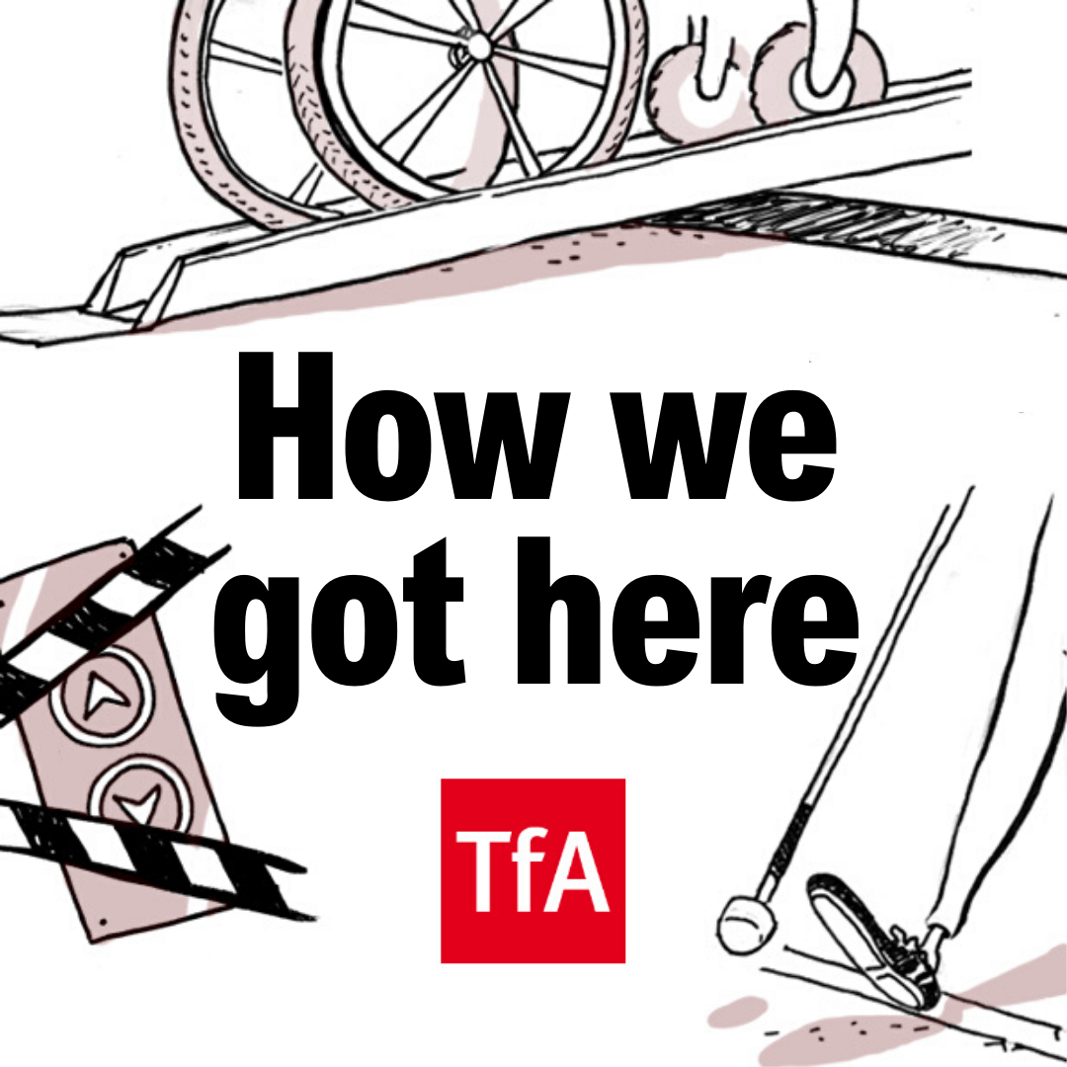

Episode 1: Mik Scarlet
Content notes: Very strong language including derogatory words for disabled. Discussion of sex. In-depth discussion of disability, illness, mortality. Brief mention of depression and suicidal thoughts + suicide attempt.

Speaker information
- Katie Pennick
- Mik Scarlet
- 2 x Staff Members
- Some background passengers.

Transcribed by Academic Audio Transcription
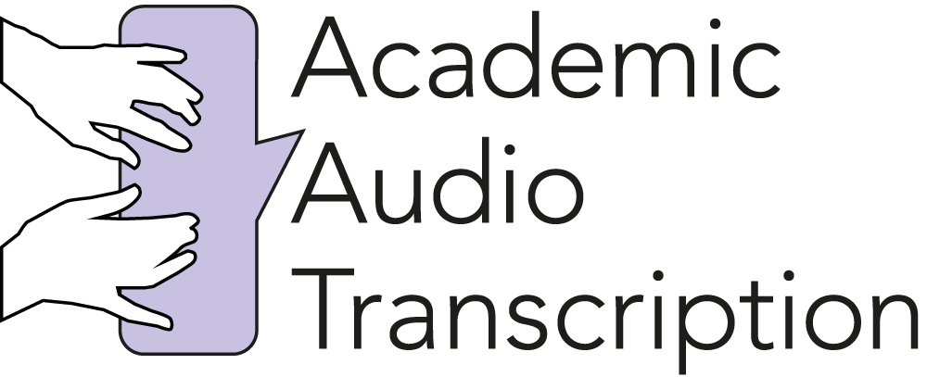

‘How We Got Here’ Transcript

Episode 1: Mik Scarlet

[Start of recording]

00:00:01 Katie This episode contains very strong language, a discussion of sex and a brief mention of suicidal thoughts.

00:00:09 Mik When I first got on the train, it was totally inaccessible. I used to have to be bumped over the tracks, lifted out—like, lifted up in my chair by two members of staff, and put in what was then called the ‘guard’s wagon’, that was made out of wood, and it was where they put the post, the luggage and the cycles. And that’s where the guard sat. And he’d have a little heater where he’d heat tea and make a pie. And I’d be in there on my own—I mean, imagine, I was a New Romantic. I was covered in make up with long hair and all weirdness, sat in this box with no windows, just open bars, so it’s freezing in winter and boiling in summer, with this guy who obviously didn’t want to be in there because he was like, [chuckling] “What the bloody hell has just landed in my guard’s van?” And then I’d arrive, and I’d have no guarantee that when I arrived anyone would get me off.

[UPBEAT MUSIC PLAYS WITH STRONG BASELINE, CYMBAL HITS, HANDCLAPS AND THEN HORNS 00:00:49— 00:01:05]

00:01:05 Katie [music bed continues] Hey. How do you get from A to B? As you’re listening to this podcast, it’s quite likely you’re on your commute. So what does that look like? Are you on the train? The bus? A taxi? How many options are there available to you?

[UPBEAT MUSIC PLAYS WITH STRONG BASELINE, CYMBAL HITS, HANDCLAPS AND THEN HORNS 00:01:18— 00:01:21]

00:01:20 Katie [music bed continues] I’m a twenty-something radio producer living in London. I’m also a full-time wheelchair user, meaning my commute can often more closely resemble an obstacle course. But like so many others like me, I’ve learned to thrive in a world that wasn’t built for me with sheer ingenuity. I’ve been asked to make a podcast by the lovely people at Transport for All, an organisation of disabled people fighting for equality, inclusive transport systems, and accessible streets for all, in London, and across the UK. In every episode of this podcast, I’m going to meet up with someone else from the disabled community, and tag along with them on a journey on public transport. En route, they’re going to share with me stories from their life, and I’ll learn how things have changed for disabled people in the UK; and just how far there is to go. I’m Katie and this is… How We Got Here. Let’s go!

[DESCENDING SYNTH HORN SCALE THEN DRUMS 00:02:18—00:02:22]

[GROOVY BLUES PIANO PIECE 00:02:25—00:02:42]

00:02:42 Katie [music bed continues] Today I’m meeting up with broadcaster, journalist, actor and musician Mik Scarlet. He is, by his own profession, a child of the Sixties, moulded by the Eighties—at least that’s what he said [chuckling] in his Twitter bio! He’s a bit of a legend, really. He also works within the transport industry to deliver disability equality training to customer-facing staff. Mik lives with his wife, Di, in Camden, but obviously seeing as there’s no accessible station there, we’re meeting here, instead, in St Pancras, as you can tell from the beautiful piano playing behind me.

[GROOVY BLUES PIANO PIECE CONTINUES 00:03:18—00:03:29]

00:03:31 Katie Hello!

00:03:31 Mik Hello Katie, how are you? Alright?

00:03:32 Katie Hi!

00:03:33 Mik Hello hello!

00:03:33 Katie How’s it going?

00:03:34 Mik Gis’ a kiss. [quick kiss on the cheek] There you go. Alright. So!

00:03:37 Katie Where are we off to?

00:03:37 Mik Here we are. We are now here in the sunny St Pancras Station.

00:03:40 Katie We are.

00:03:40 Mik And we’re going to take the Thames Link from St Pancras to London Bridge and go for a small half.

00:03:46 Katie Lovely. A small half. Lovely! [laughs]

00:03:47 Mik A small half. A quickie. A quick half.

00:03:49 Katie Not a whole pint?

00:03:50 Mik Not a whole pint, no, no, no. [laughs]

00:03:50 Katie Just a small half! So I’ve never actually got the Thames Link before.

00:03:56 Mik Haven’t you?!

00:03:57 Katie No.

00:03:57 Mik [Gasps]

00:03:57 Katie This is a first—this is a world first, for me.

00:04:01 Mik Can you do little wheelies in your chair?

00:04:04 Katie Oh God. Oh God. Um, okay, I—

00:04:06 Mik If not I’ll go behind you.

00:04:07 Katie [laughs]

00:04:07 Mik You might be able to do it easily. If not, we’ll get the bridging ramp.

00:04:11 Katie Yeah, okay, so—

00:04:11 Mik Right? But it’s…

00:04:12 Katie So it’s a manual boarding ramp type situation, is it?

00:04:14 Mik Okay. We’ll ask for that. I usually just jump.

00:04:19 Katie So we are just coming up to the turnstiles now.

00:04:23 Mik Yep.

00:04:23 Katie Oyster cards at the ready.

00:04:26 Mik That’s it. And now, in the words of radio, we’re going over to the person to ask for assistance.

00:04:32 Katie [chuckles] In the words of radio!

00:04:33 Mik In the words of radio. Oh, sorry, it’s a podcast.

00:04:36 Katie [laughs]

00:04:36 Mik See that’s, that’s showing my age, isn’t it? There’s only one type of radio, and I used to cut it with tape. Hello mate, we just wanted to request assistance. We’re going to go to London Bridge?

00:04:45 Staff 1 Where you going to?

00:04:45 Mik London Bridge.

00:04:47 Staff 1 That’s your final stop?

00:04:48 Mik Yeah. That’s it.

00:04:48 Katie That’s our final destination.

00:04:49 Mik So we’re going on a little quick jaunt.

00:04:50 Staff 1 I’m sure it will be okay.

[AUDIO FADES OUT AND BACK IN]

00:04:53 Katie So, we’ve got the lift down. We are now at the platform ready to get on our train. It’s really interesting doing this experience with you because you obviously have an inside knowledge. You deliver training to Network Rail.

00:05:06 Mik Yeah.

00:05:08 Katie What does that training involve? What do you do?

00:05:09 Mik It’s called Inclusive Service Training. It’s not about just assisting disabled people; it’s about assisting everybody. And it’s not about having us ask for it; it’s also about us having it offered to us. And that assistance is part of what makes the network accessible. So you’re not doing us a big deal if you get a ramp out. It’s actually part of what we need to use the service like everybody else. And because I travel a lot by train, I meet a lot of the people I’ve trained helping other people.

00:05:37 Katie That’s really nice!

00:05:37 Mik Assisting other people. And it’s really great to see. And it proves that if you do it, if all of the train companies did something similar, the network would open up quicker.

00:05:46 Katie Yeah.

[SOUND OF HIGH SPEED TRAIN PULLING INTO THE PLATFORM]

00:05:47 Mik Oh here it comes! There’s loads of us! It’s like a big gang!

00:05:51 Katie [laughs]

00:05:52 Mik [laughs] Alright mate?

00:05:54 Staff 2 To London Bridge?

00:05:55 Mik Yeah. Cool.

00:05:56 Katie London Bridge, that’s it.

00:05:57 Mik Yep, London Bridge, yup.

[TRAIN WHISTLE BLOWS]

00:06:03 Mik We are on the train.

00:06:03 Katie [laughing] We are on the train! We’ve had to sort of weirdly Tetris our way in [laughing from Mik and other passengers]. And this is really interesting, because I mean, you know, obviously we are on a journey together. We couldn’t have got the bus.

00:06:17 Mik No.

00:06:19 Katie Because you can’t get two wheelchairs on a bus. So I mean you are… you are a bit limited, aren’t you, if you’ve got a friend in a wheelchair?

00:06:24 Mik Yes. And that’s why this is so important, I think. Because I think the Tube and the train system, like things like Thames Link that go through the city, can really change the way you experience London.

00:06:39 Katie What are the biggest problems that you come up against while travelling? What are the, you know, the biggest obstacles that we still need to find a workaround for?

00:06:48 Mik In London it’s kind of bad, but I do think there is, that it’s slowly getting better. But because I do work all over the country, I go to places and am shocked at how bad it is. And I think that one of things is we need to have a much more nationwide approach to the investment into access. You know, I go to a lot to Leeds station, and Leeds station is accessible in, like, you know, words. But it’s very difficult to—

00:07:16 Katie In words?

00:07:15 Mik In that it’s accessible, yeah, but you try—

00:07:17 Katie Right. Technically.

00:07:18 Mik Yes. But like, the things like, the different rolling stock that go through Leeds. Because it’s a hub the different train companies have different trains. So they have to have like, about five different types of ramp to get you on different trains, and they’re all in different places, and almost—and so, and there’s lots of trains going through, so you’ve got to be—so it’s really complicated.

00:07:40 Katie That must be a nightmare to coordinate!

00:07:40 Mik Yeah. Exactly.

00:07:42 Katie Obviously you, you know, you work with Network Rail. You train the staff who are actually going to be doing these things. What are the reactions you get? You know, what do people who come into this, completely new, maybe never even met a disabled person before, what are the reactions you get? What do people tell you?

00:07:59 Mik I think… I think that’s kind of what my job is, is because I’m quite fun and lively I kind of….

00:08:04 Katie You have—

00:08:05 Mik I, when they come in—

00:08:05 Katie You are, quite.

00:08:07 Mik They’re expecting a certain thing, a quite a boring, dry day of depressing-ness, and that’s not what they get. And I think it challenges them on many levels. So everything we cover, kind of, we take what they think and then we explode it and put them back together again. And it’s happened over and over and over again through the day. So it’s… yeah. It’s a… it’s actually quite a wonderful job. You know, I used to be a TV presenter—I was famous—and I find this job more fulfilling than that, i.e. I always thought I was leaving a legacy of, you know, change, but you know, here I am, what, twenty [mumbling] years after I was a TV presenter and I’m… and it’s still the same. You know, you don’t have loads of famous disabled people. There’s a few, but there’s about the same number as there was when I was young. And the industry still doesn’t get it; it still uses all the wrong language; it still portrays us as brave and tragic and all that kind of stuff. This… I see the change.

00:09:06 Katie Yeah.

00:09:07 Mik You know, I’m getting on a train—we got on a train today that I used to use when I was your age, right, and it was totally inaccessible.

00:09:15 Katie So tell me, how have things changed? What was the situation like when you first started going out and about in London?

00:09:21 Mik Right, when I first got on a train, it was totally accessible. I used to have to be bumped over the tracks by a—

00:09:26 Katie Over the tracks?!

00:09:27 Mik —by staff members. That’s where I learned—in my hometown station, I learned that tracks sing when a train is coming, and that’s how you know.

00:09:32 Katie [gasps] Oh my God, oh my God!

00:09:33 Mik So we’d sit by the track and then we’d listen. And if they weren’t singing we could go across, and if they were, we’d have to wait. And the train would go by so close… because my toes would be almost on the train, so it would go by and the wind would nearly blow you over. So I’d be bumped across the tracks, lifted out of—like, lifted up in my chair by two members of staff, and put in what was then called the ‘guard’s wagon’.

00:09:53 Katie The ‘guard’s wagon’?

00:09:53 Mik Which was a big red box on one set of bogeys—on one set of wheels—that was made out of wood, and it was where they put the post, the luggage, and the cycles, and that’s where the guard sat. And he had a little box with a cage, and he’d have a little heater where he’d heat tea and make a pie, right? And I’d be in there on my own—I mean, imagine, I was a New Romantic. I was covered in makeup and long hair and all weirdness, sat in this box with no windows, just open bars, so it’s freezing in winter and boiling in summer, with this guy who obviously didn’t want to be in there, because he was like, “What the bloody hell has just landed in my guard’s van.” And then I’d arrive, and I’d have no guarantee that when I arrived anyone would get me off. Because it… they’d only put me on out of the goodness of their heart.

00:10:33 Katie Oh my… oh my God!

00:10:34 Mik So then I’d have to crawl off, and the number of times like things like where I’d, no one would put me on, so I’d crawl on, and as I was crawling on, and the train would leave leaving my chair on the platform.

00:10:44 Katie No!

00:10:44 Mik And people would throw my chair in! It was… it’s such a different world. But it’s a bit difficult, I think, for anyone—I mean, you imagine, I’m… I’m old. But I’m only in my fifties. I’m not like, Methuselah. So kind of, things have changed hugely in a very short space of time.

00:11:00 Katie A very short space of time.

[TRAIN ANNOUNCEMENT SAYS, “ARRIVING AT LONDON BRIDGE”]

00:11:02 Mik London Bridge! We’re here!

00:11:03 Katie Ah, there you go! Next stop!

00:11:05 Mik That’s it.

00:11:06 Katie I can’t get my head around the image of a teenage you, face full of makeup, being chucked onto a, in a cage with a load of post? [laughs]

00:11:17 Mik Yeah. Yeah, little bags, sacks of post. You know, if…

00:11:20 Katie I mean it just sounds ridiculous.

00:11:22 Mik Yeah, well, that was it was like. But the thing is that was because there was absolutely no requirement to carry you, so there wasn’t any consideration to carry you.

00:11:29 Katie No.

00:11:30 Mik But what was really funny was then, sort of in the late Eighties and early Nineties, this line opened, and they brought out rolling stock that was totally level at all stations. So from then I went from that, to being able to wheel on and off the train completely, but they put the station underground, so I had to go to Blackfriars, get off at Blackfriars, then when I wanted to go home, get back on at Blackfriars, go south, and then turn around and go back to north.

00:11:55 Katie So this line actually has quite a special place in your heart?

00:11:58 Mik Yes. Which is why I brought you on it! And so here we are!

00:12:00 Katie Here we are! Another!

00:12:01 Mik Let’s jump off! Right, there you go. I’ll go first. Hold on, let me just make sure—oops, sorry mate. You okay?

00:12:09 Katie Just. Yeah.

00:12:09 Mik Wahey!

00:12:09 Katie Totally fine.

00:12:10 Mik Now the weird bit: we go against all the traffic.

00:12:13 Katie Oh, I see.

00:12:13 Mik The only flaw in their cunning plan, my lord.

00:12:16 Katie [laughs] Just to describe this for you, there’s a big crowd—

00:12:19 Mik There you go, see look, right.

00:12:19 Katie —and me and Mik, two wheelchair users kind of ploughing through.

[UPBEAT MUSIC WITH ENERGETIC TAMBOURINES 00:12:26—00:12:31]

00:12:31 Katie We’re going, heading into the lift.

00:12:33 Mik Right, you’ve got two of us, a cycle, luggage, more push chairs. It’s all coming in because the lift is not the size of a small postage stamp.

00:12:42 Katie No.

00:12:43 Mik Everyone in? Going down!

00:12:47 Passenger This is great, this is really, really good!

00:12:49 Passenger [laughs]

00:12:49 Mik Every now and again, when the lift breaks, I go down the escalator.

00:12:53 Katie You don’t?

00:12:54 Mik I do. I do.

00:12:54 Katie That is a long escalator!

00:12:55 Mik Much to the consternation of the staff, because you shouldn’t really do it, right? [Laughing from other lift occupants] But let them tell me I won’t. And the problem is that it’s—

00:13:01 Passenger It’s still punk!

00:13:03 Mik Still punk. [Chuckles]

00:13:04 Katie Still punk! Is that, is that the modern definition of punk, going down an escalator on your wheelchair? [laughs]

00:13:07 Mik [laughs] Yeah! But, because it’s so long, you jump on it and go, “Yeah, I’ll be fine.” And then you get sort of like, about halfway and think, “Oh, bugger, this is long!” [laughs]

00:13:17 Katie Oh my God!

00:13:18 Mik But it’s still worth it to see all the faces of the people behind you! After you!

00:13:21 Katie [laughing] That is….

00:13:27 Mik So here we are in sunny London Bridge, and we are now witnessing one of the key elements of such a big station, is all of the bipeds who are running into us. It is actually a lot like Whack-A-Mole, here.

00:13:37 Katie [laughing] Whack-A-Mole!

00:13:37 Mik In that you wheel along, and you have no guarantee that at any point you won’t actually get someone land on your lap or fly over you.

00:13:43 Katie That happened to me this morning. Someone ended up in my lap—in my lap! I don’t want someone in my lap.

00:13:51 Mik Get in there! Get in there!

00:13:52 Katie I learned the word ‘biped’ from you and I’ve started to referring to my boyfriend as my biped.

00:13:58 Mik Yeah, it upsets Diane quite a lot because I don’t say it in a friendly manner. I’m like, “Bloody bipeds,” and she goes, “But you’ve married a biped!” And it’s like yeah, but you know. Some of you are alright. [laughs]

00:14:07 Katie Not all—not all bipeds!

00:14:09 Mik [laughs]

00:14:11 Katie Oh, okay. I know where we’re going. I know where we’re going.

00:14:12 Mik Because you know where we’re going.

00:14:13 Katie I do know where we’re…

00:14:13 Mik I know we want beer; you know where we’re getting beer. This is a good combination.

00:14:17 Katie [laughs] Okay.

[UPBEAT MUSIC WITH ENERGETIC TAMBOURINES 00:14:17—00:14:23]

00:14:22 Katie So, made it to the pub.

00:14:24 Mik We did.

00:14:25Katie You’ve got a pint.

00:14:26 Mik We have. I have, I’ve got a whole pint. I’ve gone full on.

00:14:30 Katie Going back to the beginning, what is, what was your first memory of disability?

00:14:35 Mik I mean I’ve been disabled since birth, but I could walk. I walked with a limp and I wore a calliper. I suppose my first real understanding of being disabled was when I went to school. I turned up and everyone started taking—you know, bullying me about my leg. Leg braces now are all plastic and groovy, but I had the same calliper that the—you’re like a little child with a metal brace on their leg.

00:15:00 Katie Like a Forrest Gump situation?

00:15:02 Mik Yes, yes, I had one of those, and it would fall apart all the while. And so I used to take a toolkit, oil, and loads of gaffer tape with me to strap it all back together.

00:15:12 Katie Wow.

00:15:12 Mik So I had to fix so I could go home. So I used to get bullied. I used to get called ‘Screw Leg’ [chuckling]. And I used to—

00:15:15 Katie Screw Leg?

00:15:16 Mik Like, because my leg would—my screws would fall out and then I’d fall over, and they’d go, “Oh, Screw Leg’s broken again.” And I… I used to be made to do sport. We used to go out and play rugby, and it, like, obviously rugby is in winter. So you’re in a muddy field.

00:15:30 Katie Yup.

00:15:30 Mik I had a metal leg that rusted because my leg was made of iron.

00:15:33 Katie Oh God!

00:15:33 Mik It wasn’t made of steel. So I’d stand in the mud and then I’d come back to, like, the school, and have to take my leg apart and oil it to stop it rusting up, because otherwise it seized. So I’d be there. No one would give me the ball or play with me, because it was like, “Well I don’t want to play with him because he’s only going to lose it, silly sod.” So I would just stand, for an hour, in the rain, while everyone played sport around me.

00:15:54 Katie Getting a rusty leg.

00:15:54 Mik I was brought up by a mum that said to me that being disabled didn’t make me less; it made me more. And so I’d go to school, and when someone said, “Oh, you can’t do something,” I’d think, “Well, why not?” Why shouldn’t I be able to do something? So then, when I was fifteen, my spine collapsed because of the treatment I had as a baby with the cancer, and that left me as a wheelchair user. And so—

00:16:17 Katie And that was time—when you were fifteen, that was the time at which you became a wheelchair user?

00:16:21 Mik Yeah. And that was when everything became quite shocking, because suddenly I’d gone from being able to limp around the world to not being able to get in anywhere, being treated very different. People suddenly started—I mean, everyone always sort of patted me on the head and went, “Ah there, poor little cute disabled boy,” but now they were like, [putting on a voice] “Oh it’s so sad and tragic.” And I genuinely believed the myth of what the future would be for me, and I believed that my life was over.

00:16:44 Katie You believed that?

00:16:44 Mik I didn’t think I’d get a girlfriend; I didn’t think I’d get a job. I… because that’s—

00:16:49 Katie And what year was this?

00:16:51 Mik 1981.

00:16:52 Katie And that was your idea, you just thought that’s it, you can’t do anything?

00:16:54 Mik Yeah. I thought that’s it, over. Over. And I got really depressed. I tried to kill myself. And I had to learn that just because I couldn’t do something the way I used to do it didn’t mean I couldn’t do something.

00:17:05 Katie This is an impossible question because I don’t think I would be able to answer this, but I’m going to ask you anyway. You obviously went from being in a position where you thought, “That’s it, my life is over, I can’t do anything, I’m never going to get a girlfriend, I’m never going to get married, never going to do a job, never going to do this,” and that kind of perspective. Obviously, you’ve gone on and done all those things, and your perspective now is completely different.

00:17:30 Mik Yeah. Yeah.

00:17:31 Katie How… [chuckling]?

00:17:32 Mik How did I…?

00:17:33 Katie What is that?

00:17:33 Mik How did you do it?!

00:17:33 Katie How did you do it?! What’s the secret?

00:17:36 Mik It’s funny because everyone I meet who is disabled goes, “Well, it’s alright for you, you’re really confident.” And I don’t—and they never really get the full story that I didn’t used to be. You know, I used to lay in bed and cry myself to sleep. Like I said, I genuinely tried to kill myself at least twice because of the fact that I believed the myth that you are taught. Because I was kind of the least disabled disabled person you could be, and I was in a nondisabled world: my school was mainstream, all my friends were not disabled, I didn’t know anyone disabled. The only—so the only messages I got about disability were from people who weren’t disabled. I also, when I was in hospital, was told I was dying, and it transpired they’d made a mistake and I wasn’t.

00:18:16 Katie Oh my God. What? [gasps]

00:18:17 Mik But for a week, I was dying. So what it meant was, I learned what it was as a fifteen year old virgin who had never dyed his hair or gone our done anything, because I was the most swotty little kid you’d ever met.

00:18:27 Katie You were a square!

00:18:28 Mik I was a real swot. Well, I remember laying in bed when he told me and thinking, “I’ve never dyed my hair, I’ve never been to a nightclub, and I’ve never had sex with a beautiful woman.” Because in my world, you had to have dyed hair and be in nightclubs to meet girls to have sex with them [laughs]. So it was that way. So when I came out and I wasn’t dying, once I got over that first depression, and once I started realising that… I found music. I… I got a huge back paycheque for what was then called Mobility Allowance and Attendance Allowance, because we’d applied when I was twelve and my parents were told I wasn’t disabled enough, and then they looked back and went, “Oh, no, he was, sorry.” So I got three years’ of money, four years’ of money paid at once. And my parents said, “You can have that, spend it on what you’d like.”

00:19:15 Katie Oh God.

00:19:14 Mik So I bought a synthesiser and a drum machine.

00:19:16 Katie [laughs]

00:19:17 Mik And I sat at home and taught myself to do basically what Depeche Mode was doing at the time. So I just basically stayed at home while I got well enough to go out, because I was really ill. I mean, I was encased in plaster for a year. Yeah, things were really touch and go. And I just went, music, music, music, music, music. Then when I got well enough to go out, the first time I left the house I went to go to the cinema, and the cinema I went to wasn’t accessible. And the manager came out and he was lovely. He was really apologetic, and he said, “Would you like to come and help us make it accessible?” So the next week I went down and we designed the route. You go through the back door, bang on the door, we’ll let you in. You get a free ticket.

00:19:57 Katie Nice.

00:19:58 Mik And then there’s a special place to park a wheelchair, if you want to sit in a wheelchair. And we did that, and so a month later, I went to the cinema to see a film.

00:20:07 Katie What did you see? Can you remember?

00:20:09 Mik Believe it or not I saw Outland, which is a science fiction film with Sean Connery. If you haven’t seen it, it’s actually quite good, but it’s a [chuckling] very depressing film to see when you’re a depressed wheelchair user, because… but it was kind of—it made me realise—I mean, I love science fiction and I was very much into it, and comics and all that. So one, it made me realise I could live the life I wanted to live. But two, it made me realise that it wasn’t me that made me disabled, it was the world around me. Because I went from not being let in a cinema to being let in a cinema in a month, and you could make the world accessible by getting people to engage with you. So there I am, and so I’m still depressed, I’ve not got a girlfriend, I still look like shit, I’m still really ill, but I’ve suddenly realised that I can make the world a better place, and that’s what made me stop being depressed.

[ATMOSPHERIC XYLOPHONE MUSIC 00:20:53—00:20:59]

00:20:59 Mik I lost the ability to get erections when my spine collapsed, and I genuinely thought, “Right, that’s it, no girl is going to want me because sex is all about making babies and sticking things in other things,” if you know what I mean. But I had lots of friends who were lesbians, and we were at a party and we were all a bit drunk, and [chuckling] we were playing Spin the Bottle, Truth or Dare. And it fell on me, and they said, “What do you want, truth or dare?” And I just told them the truth; I told them this secret that I’d kept. And they all fell about laughing. And then they said, “Look, Mik, remember, none of us have a penis. We all fuck each other bandy.” Excuse my French, folks. That’ll be edited out, that’ll be bleeped. And I was like, “What?” And they went, “Yeah, what do you think we do with each other?” And I was like….

00:21:43 Katie [makes explosion noise]

00:21:43 Mik And all of a sudden I had this—and I was like, “Oh my God you totally stupid bastard.” And it was, I had this awakening where I suddenly thought, “Oh you mean…?” Because everyone, especially in my generation, found lesbianism very terrifying because of course they were going to take over the world and eradicate men.

00:21:57 Katie Yeah.

00:21:59 Mik And they, they were very, very politically aware. And people probably don’t realise but in the Eighties there was a huge movement of lesbianism that believed—lesbian feminism was very radical, and it believed that all men were rapists and penetration was rape. So I was now officially not a man; I was something more evolved. And suddenly this thing that I hated because this thing—I went to all these parties with these girls! I went to Pride and was at the front of the lesbian feminist march, holding a banner!

00:22:28 Katie [laughs]

00:22:28 Mik You know, “MEN ARE BASTARDS!” And I was there. And in the end, one night—

00:22:35 Katie An honorary lesbian!

00:22:35 Mik No, I did become an honorary lesbian. It changed my… that idea that I was… and again, we’re back to that idea of thinking what normal is.

00:22:44 Katie Yeah.

00:22:44 Mik I thought normality was what I’d been taught about sex in a book in biology when I was fifteen. Two years later I learned that sex is whatever you want to make it. I think that was a moment where I realised that actually it’s going to be alright. And I think my life has been a succession of those.

00:23:01 Katie Of moments where you realise that it’s going to be okay?

00:23:02 Mik Realised it’s going to be alright. Yeah, it’s like when I met my wife, we kind of talked and agreed that I would become open about what does and doesn’t work, because for years I’d denied it. And then suddenly I came out about all this stuff, and that was really joyous, because one, I could be myself, but also, I discovered that all of my nondisabled friends would all come up to me afterwards and go, “You know you have problems getting erections? So do I.” And it was like, “Oh you bastards! You’ve all been talking about all this stuff that you don’t do,” right? And it made me realise that we, as a community, have a lot more experiences in common with those people who aren’t disabled because they just don’t like admitting that their bodies are as crap as ours.

00:23:44 Katie [laughs]

[ATMOSPHERIC PIANO MUSIC 00:23:46—00:23:52]

00:23:52 Katie I think there’s a big overlap between sexuality and disability. I think this like… and it all comes down to normality.

00:24:00 Mik Yeah.

00:24:00 Mik And what people just think of as ‘normal’ and ‘usual’ and therefore there is nothing outside of that. And, or people just aren’t willing to open their minds to what is outside of that. And it—genuinely, it harms everyone.

00:24:15 Mik Yeah. I genuinely think the social model applies to everybody. I think that whatever your ethnicity, whatever your gender, whatever your wealth, whatever your intelligence, everything about—all the little elements that make up those sections of society that make us different, are also the things… they are all social constructs. We live in a world where we are told our place and we’re made to fit in it, and I’ve always believed that that’s all rubbish. You can do whatever you like. Yes, we have barriers, but if you’re really good at something you will get to a point where people see how good you are. And I think that, now more than ever, we are at a point where people do that. And I think the younger generations of disabled people are—probably this generation, your generation, say—are the first generation where you can shine. And you’ll get all the bullshit that we all got, but it won’t be enough to stop you shining. I mean, I remember in 1998, I went to, for a job presenting Watchdog, and the series editor said, “We don’t have an effing cripples on our show.”

00:25:23 Katie [gasps]

00:25:23 Mik Only a couple of years later they got someone because he got well and truly fired for that because I made a formal complaint. But that’s what it used to be like. That was—we used to—it wasn’t—discrimination wasn’t like, subtle, like it is now. It was like, in your face, proper, you know, “Fuck off, Spazmo.” And [chuckles] and that was, this wasn’t like, just from like, you know, bullies. This was from people in power. And we did that. We got rid of that. The campaigners, the, you know, the people that chained themselves to buses and threw paint. And you know, I wasn’t part of that scene and I kind of regret that I wasn’t. I had got into television so early and within television you couldn’t’ be a TV presenter and a… arrested political campaigner because you wouldn’t work.

00:26:08 Katie Mm, strapping yourself to buses.

00:26:08 Mik Exactly. So I would tend to interview them. And, I mean, it was one of them that taught me about the social model. I was at an event, and there were lots of campaigners there, and I was never really that popular with the political lot. And one of them, she trapped me in a lift in her giant powerchair. So I wheeled in, then she wheeled after me, and then the doors shut, and she went, “Right, you don’t know why we don’t like you, do you?” And I was like [puts on a weepy voice] “No, I don’t!” And she was like, “Right, I’m going to tell you.” And so we were in this lift, and it went up and down, and the doors would open, and she’d just turn around to all these… bipeds who were trying to get in and go, “Wait!” And then we’d just go up. And we went up and down for about ten minutes. And she explained the social model, disability politics.

00:26:49 Katie Wow.

00:26:49 Mik And I went in that lift one person and I came out another. And I genuinely did. It was like, it was a road to Damascus moment.

00:26:55 Katie That’s amazing.

00:26:55 Mik And it’s why I’m so evangelical about equality. Because I went in a lift filled with self-hate, internalised ableism, that view that I wasn’t like them, that I wasn’t… that I wasn’t part of the disabled community because I was better than them, I was different. I wasn’t like them; I was special. You know? And I came out, “Oh my God, I’m not having this! You blind traitor!” And I just—and from that day onwards, I have been absolutely full pelt, trying to make up for all the mistakes I made before, because I made a lot of them when I was very famous. I mean, I’ve got video at home which I’ve never put online because I daren’t, where it’s the second thing I’d ever filmed for ITV, and I come out and I say, “Well, when handicapped people want to do sport….” And I watch it—and I’ve got it on video so I can watch it to remind myself of how far I’ve come and why it’s so important when you’re engaging with people that don’t get it, to try not to get angry with them, because I used to be that person. Because I used to be that person. “Oh, well no, I’m not disabled.”

00:28:00 Katie It’s so interesting listening to you talk about this because I, I have the exact same experience. I, all my life, I distanced myself from disability. I never called myself ‘disabled’. I did not consider myself disabled. I absolutely—I squirmed at the word. And, you know, exactly the same as you, a really like, mainstreamed upbringing. Mainstream school, everything. And I’d—and people would say, “Oh, I don’t see you as disabled. You’re not like that.”

00:28:26 Mik Yes. And you’d see at as a compliment.

00:28:27 Katie And I’d see it, I’d always be like, “Yes, I know that I’m not!”

00:28:30 Mik Damnit!

00:28:30 Katie Because I’m not like that. I’m… I’m different. I’m basically just, you know, I’m the same as everyone else.

00:28:33 Mik Yes. That’s it.

00:28:34 Katie I’m normal. I’m normal!

00:28:36 Mik “I’m not disabled. I’m Mik.” Or, you know, “I’m Katie.”

00:28:38 Katie Yeah!

00:28:39 Mik I’m a person who has transcended the lack that my body has given me. And that’s… yeah.

00:28:45 Katie [laughs] Exactly! And it was so damaging because I just, I… I just hated myself.

00:28:53 Mik Yeah, yeah. I used to go clubbing, right. And this was before it was illegal to not let you in. So you could be stopped. But I would get in because I would go, “Nah, it’s alright, I’ll crawl down the stairs.” Like, say we’re in this pub. You’ve got a flight of stairs. I’d crawl up them to go to the—say the nightclub was upstairs. And then I’d crawl into the toilet through the urine that everyone had put all over the floor, soaked with piss. I wouldn’t care.

00:29:16 Katie No!

00:29:17 Mik Right?

00:29:18 Katie That’s horrible!

00:29:18 Mik And I would do anything to go because being like my friends was more important than trying to make a change. What I used to do as well was, there used to be a set of water pipes that run through the ceiling, and I would hang onto them and monkey-swing through it and then lean on the wall and then hope that—one of my legs I could lock. So I’d lock my leg—

00:29:37 Katie What?!

00:29:37 Mik —and hope I didn’t fall over to go to the loo.

00:29:39 Katie What is this…? What?

00:29:40 Mik Exactly. But that’s the, the thing is right—

00:29:41 Katie This is horrendous.

00:29:42 Mik —is you have to do that to know how it used to be to know that that’s really wrong, right? Now it drives my wife up the wall because I won’t do it because it’s not right. And so, she’s like, “Well you used to do it?” And I’m like, yeah I know, I’m not… I could probably do it again—though I’m getting a bit old, so I think I’m fat, so there’s a lot more bulk to hang. I’d probably pull the pipe off the wall! But I’m not doing it because it’s not right. It’s not legal. And again, we’re back to this thing where we need to educate everybody why it’s so important. It’s not fair to have… it shouldn’t be fair that your generation has to go through what mine did. It’s not fair that the next generation will go through what we both did. It can’t be right.

[ABSTRACT CELLO MUSIC 00:30:29—00:30:34]

00:30:34 Katie I wanted to ask you about something specific. There were comments made by a very famous American TV anchor, Dr Phil, about relationships.

00:30:45 Mik Oh, yes. Yup.

00:30:47 Katie About specifically the relationships between ablebodied and disabled people, saying that you cannot be a caregiver and a lover, and saying that those relationships will fail.

00:30:58 Mik The, so the Dr Phil thing really troubled me, because that concept is what I woke up to as a fifteen year old with my spine collapsed. I believed that no one would want to be with me because I had suddenly become a burden. And so having someone—I mean, don’t forget that’s nearly thirty, forty years ago for me, right? To have someone forty years later after I went through that terribly depressing phase, I can’t believe—this bloke is supposed to be someone that’s meant to be doling out advice and support and help, and this is what we are still up against. But at the end of the day that is a perfect example of why our society has got so far to go.

00:31:43 Katie Because he—to just quote him there—because he….

00:31:47 Mik [laughs] Well you’ve got that quote on your phone!

00:31:47 Katie [laughing] I’m literally opening up my notes!

00:31:49 Mik This is good research, folks, good research!

00:31:54 Katie He spoke to a woman who was in a relationship with a disabled man, and he brought her onstage before he brought on the disabled man.

00:32:01 Mik Yup, yup, yup.

00:32:03 Katie And put a question to her saying, “You,”—and this is to quote—“you’re young, single attractive, female. Out of all the people that you can choose, why choose someone in a wheelchair?”

00:32:13 Mik Many, many years ago I remember being—it happened a lot—but it happened, one night I remember specifically I was in a club and I was with my partner at the time, and she was not disabled. And a guy came up to me, to us both, and said, “What are you with him for? Why aren’t you with me or someone like me, like with a real man?”

00:32:33 Katie [gasps]

00:32:33 Mik And… she didn’t reply which made me realise that she was not the right girl for me. That’s always been an attitude that people have. Why are you with that bag of crap? And that’s the thing that really bugs me, the idea that we can’t be seen as ‘better than’. I know that I bring something to a relationship that many of my friends who aren’t physically like me don’t, can’t. And that comes from things like being told you’re going to die at fifteen. We bring something to society that society really needs, and it needs it now more than ever. We bring an understanding of difference, of outside-ness, of otherness, and of difference. So what if you and me get around differently? So what if we go to a different sized toilet or we, you know, have to get on a thing differently? That’s what everybody—everyone’s different. If we embrace that we embrace the talent and the wonder of our society, and we end up with a world where true talent will win. It won’t be, “I went to Eton.” It’ll be, “I am the best person for this job.” And how we do this job will match my skill, not match what it says on a piece of paper. And if I do one thing at Network Rail, it’s going to be that.

00:33:57 Katie [laughs] Mik Scarlet, thank you so much for speaking with me today. It’s been great.

00:34:01 Mik Thank you very, very much, and well done for stopping me talking! [laughs]

[UPBEAT MUSIC WITH HANDCLAPS AND FUNKY BASSLINE 00:34:07—00:34:13]

00:34:13 Katie [music bed continues] That was the brilliant Mik Scarlet opening up over a couple of frosty pints in the pub in London Bridge. In the next episode, I’ll be jumping on the Jubilee line with the peer and Paralympic athlete Baroness Tanni Grey-Thompson and following her into work which is, of course, the House of Lords. It’s a completely calm and slow time for politics at the moment, so I’m sure there’ll be absolutely no issues there. [chuckles] Subscribe now so you don’t miss any of that or any other episodes. Just search, ‘How We Got Here’ wherever you get your podcasts and hit subscribe.

[UPBEAT MUSIC WITH HANDCLAPS AND FUNKY BASSLINE 00:34:47—00:34:50]

00:34:51 Katie [music bed continues] Well, if I’ve peaked your interest with any of the issues covered in this episode—transport, access, equality for disabled people—and you’d like to find out more about the brilliant work that Transport For All does, just search for them online or on Twitter and get involved. Transport for All want your support, and your voice, to dismantle disabling barriers to transport. So please, follow them online and sign up as a member, and join a fantastic community of people campaigning for change. I’m Katie Pennick, and I’ll see you next time.

[UPBEAT MUSIC WITH HANDCLAPS AND FUNKY BASSLINE 00:35:24—00:35:33]

[End of recording]

